Global Harmful Gas Emissions

Ami Doshi

Abhinav Sharma

## Project Summary

The purpose of this project is to highlight the different kinds of harmful gasses present in the environment with respect to specific countries and the effect they can have on the environment and its members i.e. Humans, Animals, Water bodies, Ozone layer, Marine life, Land, etc.

In this project we will also look at various solutions implemented by different countries which have managed to achieve low level of carbon emissions. This data can be used to draw a comparison between a country with high carbon emission rate and a country with low carbon emission rate. Hence, it can help us identify what solutions the country with high carbon emissions can put in place to help reduce its carbon emissions.

The Database produced in this project can be made public for researchers and general global population for the purposes of awareness. Governments of the concerned countries can access this database and determine their plan of action for reducing carbon emissions to increase the quality of life for their citizens.

To narrow down the scope and better help the countries at risk to identify their harmful gas emission risks and its effects on health of humans, animals, marine life and Ozone layer, we will be specifically focusing on Carbon Dioxide, Carbon Monoxide, Sulphur Dioxide, Nitrogen Dioxide and CFC gases for harmful gas emissions.

## Entity and Attribute Table

## Table 1 - Gas_MasterTable

|  |  |  |  |  |
| --- | --- | --- | --- | --- |
| **Table Name** | **Description** | | | |
| **Gas_MasterTable** | **Master Table maintaining the various gas names available** | | | |
| **Attributes** | **Key** | **Field Type** | **Null/Not Null** | **Explanation** |
| GasID | **Primary Key** | int | Not Null | Unique Identifier for Gas |
| GasName |  | varchar(200) | Not Null | Name of Gas |
| GasDescription |  | varchar(300) | Not Null | Description of Gas |
| Usage |  | varchar(200) | Null | Where the gas is used etc. |

Table 2 - GasHazardLevel_MasterTable

|  |  |  |  |  |
| --- | --- | --- | --- | --- |
| **Table Name** | **Description** | | | |
| **GasHazardLevel_MasterTable** | **Maintains the Hazard level of the Gas emission. It helps map the percentage of emission a particular gas to a safe, high or critical level** | | | |
| **Attributes** | **Key** | **Field Type** | **Null/Not Null** | **Explanation** |
| HazardID | **Primary Key** | int | Not Null | Unique Identifier for Hazardous gas |
| GasID | Foreign Key | int | Not Null | Unique Identifier for Gas |
| SafePercentLevel |  | int | Null | Percentage level considered safe |
| HighPercentLevel |  | int | Null | Percentage level considered high |
| CriticalPercentLevel |  | int | Null | Percentage level considered critical |

Table 3 - Country_MasterTable

|  |  |  |  |  |
| --- | --- | --- | --- | --- |
| **Table Name** | **Description** | | | |
| **Country_MasterTable** | **Country Master Table holds the data of all the countries including their present government type.** | | | |
| **Attributes** | **Key** | **Field Type** | **Null/Not Null** | **Explanation** |
| CountryID | **Primary Key** | int | Not Null | Unique Identifier for |
| CountryName |  | varchar(100) | Not Null | Name of Country |
| CountryContinent |  | varchar(100) | Not Null | Continent in which the country is |
| CountryPopulation |  | int | Null | Population of the country |
| CountrySizeInKm |  | int | Not Null | Size of the country in square Km |
| Currency |  | varchar(100) | Not Null | Currency used in the country |

Table 4 - Solution_MasterTable

|  |  |  |  |  |
| --- | --- | --- | --- | --- |
| **Table Name** | **Description** | | | |
| **Solution_MasterTable** | **Holds the current known solution to the carbon emission problems** | | | |
| **Attributes** | **Key** | **Field Type** | **Null/Not Null** | **Explanation** |
| SolutionID | **Primary Key** | int | Not Null | Unique Identifier for Solution |
| SolutionName |  | varchar(100) | Not Null | Name of the Solution |
| Description |  | varchar(200) | Null | Description of Solution |

Table 5 - GasEffects

|  |  |  |  |  |
| --- | --- | --- | --- | --- |
| **Table Name** | **Description** | | | |
| **GasEffects** | **The effects from carbon emission that are known so far have been documented here irrespective of their country, or whether the effects of using the gas is good or bad. E.g. effect could be Cancer or melting of glacier.** | | | |
| **Attributes** | **Key** | **Field Type** | **Null/Not Null** | **Explanation** |
| GasEffectID | **Primary Key** | int | Not Null | Unique Identifier for Gas Effect |
| GasID | Foreign Key | int | Not Null | Unique Identifier for Gas |
| EffectName |  | varchar(50) | Not Null | Name of Effect |
| EffectDescription |  | varchar(200) | Null | Description of Effect |
| PositiveOrNegativeEffect |  | varchar(20) | Not Null | Whether the effect is positive or negative |
| EffectsOnType |  | varchar(100) | Not Null | Type of Effect |

Table 6 - Death

|  |  |  |  |  |
| --- | --- | --- | --- | --- |
| **Table Name** | **Description** | | | |
| **Death** | **When the effects of a carbon emission affect humans or animals, the death toll so far should be considered.** | | | |
| **Attributes** | **Key** | **Field Type** | **Null/Not Null** | **Explanation** |
| GasEffectID | **Primary Key**, Foreign Key | int | Not Null | Unique Identifier for Gas Effect |
| CountryID | **Primary Key**, Foreign Key | int | Not Null | Unique Identifier for country |
| DeathToll |  | int | Not Null | Death count |

Table 7 - EnvironmentEffect

|  |  |  |  |  |
| --- | --- | --- | --- | --- |
| **Table Name** | **Description** | | | |
| **EnvironmentEffect** | **When effects of carbon emissions affect Glaciers, Temperature, Water levels, level of change is considered** | | | |
| **Attributes** | **Key** | **Field Type** | **Null/Not Null** | **Explanation** |
| GasEffectID | **Primary Key**, Foreign Key | int | Not Null | Unique Identifier for Gas Effect |
| CountryID | **Primary Key**, Foreign Key | int | Not Null | Unique Identifier for country |
| LevelChange |  | varchar(6) | Not Null | Level of Change |

Table 8 - SolutionForEffects

|  |  |  |  |  |
| --- | --- | --- | --- | --- |
| **Table Name** | **Description** | | | |
| **SolutionForEffects** | **Solutions for different gas effects is documented, while maintaining on whom it’s effect.** | | | |
| **Attributes** | **Key** | **Field Type** | **Null/Not Null** | **Explanation** |
| SEID | **Primary Key** | int | Not Null | Unique Identifier for SolutionForEffects Table |
| SolutionID | Foreign Key | int | Not Null | Unique Identifier for Solution |
| GasEffectID | Foreign Key | int | Not Null | Unique Identifier for Gas Effect |
| EffectOnType |  | varchar(50) | Null | Effect on Type |

Table 9 - SolutionImplementedByCountry

|  |  |  |  |  |
| --- | --- | --- | --- | --- |
| **Table Name** | **Description** | | | |
| **SolutionImplementedByCountry** | **Solutions for effects in different countries is documented, while maintaining its year and whether the results were positive or not based on the solution.** | | | |
| **Attributes** | **Key** | **Field Type** | **Null/Not Null** | **Explanation** |
| SCID | **Primary Key** | int | Not Null | Unique Identifier for SolutionImplementedByCountry Table |
| SolutionID | Foreign Key | int | Not Null | Unique Identifier for Solution |
| CountryID | Foreign Key | int | Not Null | Unique Identifier for country |
| GasID | Foreign Key | int | Not Null | Unique Identifier for Gas |
| Year |  | int | Null | Year in which the solution was implemented by the country |

Table 10 - CountryGasEffects

|  |  |  |  |  |
| --- | --- | --- | --- | --- |
| **Table Name** | **Description** | | | |
| **CountryGasEffects** | **Contains a list of countries and gases which affect those countries and to what extent** | | | |
| **Attributes** | **Key** | **Field Type** | **Null/Not Null** | **Explanation** |
| CGE_ID | **Primary Key** | int | Not Null | Unique Identifier for CountryGasEffects Table |
| CountryID | Foreign Key | int | Not Null | Unique Identifier for country |
| GasID | Foreign Key | int | Not Null | Unique Identifier for Gas |
| Air Quality |  | varchar(50) | Not Null | Quality of air |
| GasPercentage |  | int | Null | Amount of Gas in ppm |
| GasEmmitedByIndustry |  | varchar(3) | Null | Whether the Gas is emitted by Industries |
| GasEmmitedByAgriculture |  | varchar(3) | Null | Whether the Gas is emitted by Agriculture |
| GasEmmitedByHousehold |  | varchar(3) | Null | Whether the Gas is emitted by Households |
| YearOfRecord |  | int | Not Null | Year in which the data was recorded |
| HazardLevel |  | varchar(6) | Not Null | Level of the Hazard that the gas poses |

## Relational Data Model

## 

## Creating Tables

--1. Creating Master Tables

Create Table Country_MasterTable(

CountryID int IDENTITY(1,1) PRIMARY KEY, --Auto increment

CountryName varchar(100) NOT NULL,

CountryContinent varchar(100) NOT NULL,

CountryPopulation float NULL,

CountrySizeInKm2 float NOT NULL,

Currency varchar(200) NOT NULL,

);

Select * from Country_MasterTable;

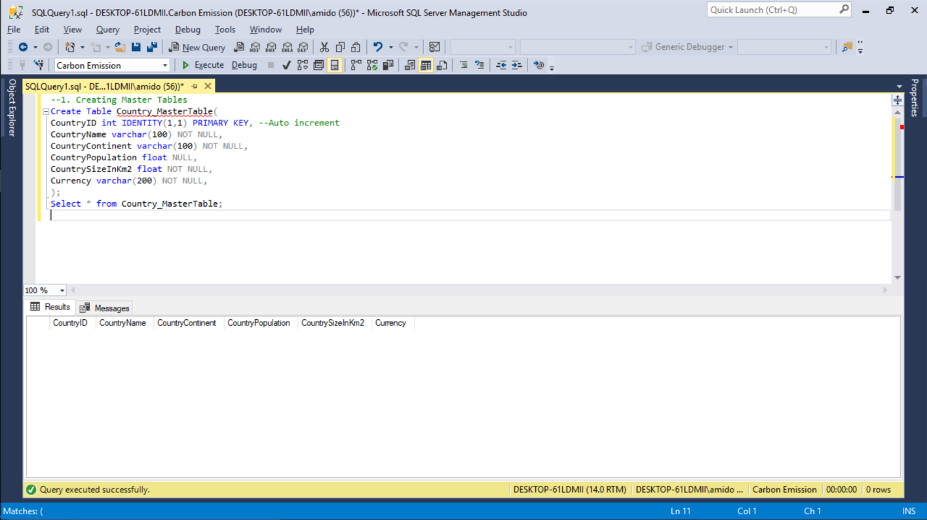

--2. Create table Gas_Mastertable

Create table Gas_Mastertable(

GasID int IDENTITY(1,1) PRIMARY KEY,

GasName varchar(200) NOT NULL,

GasDescription varchar(300) NOT NULL,

Usage varchar(200) NULL

);

Select * from Gas_Mastertable;

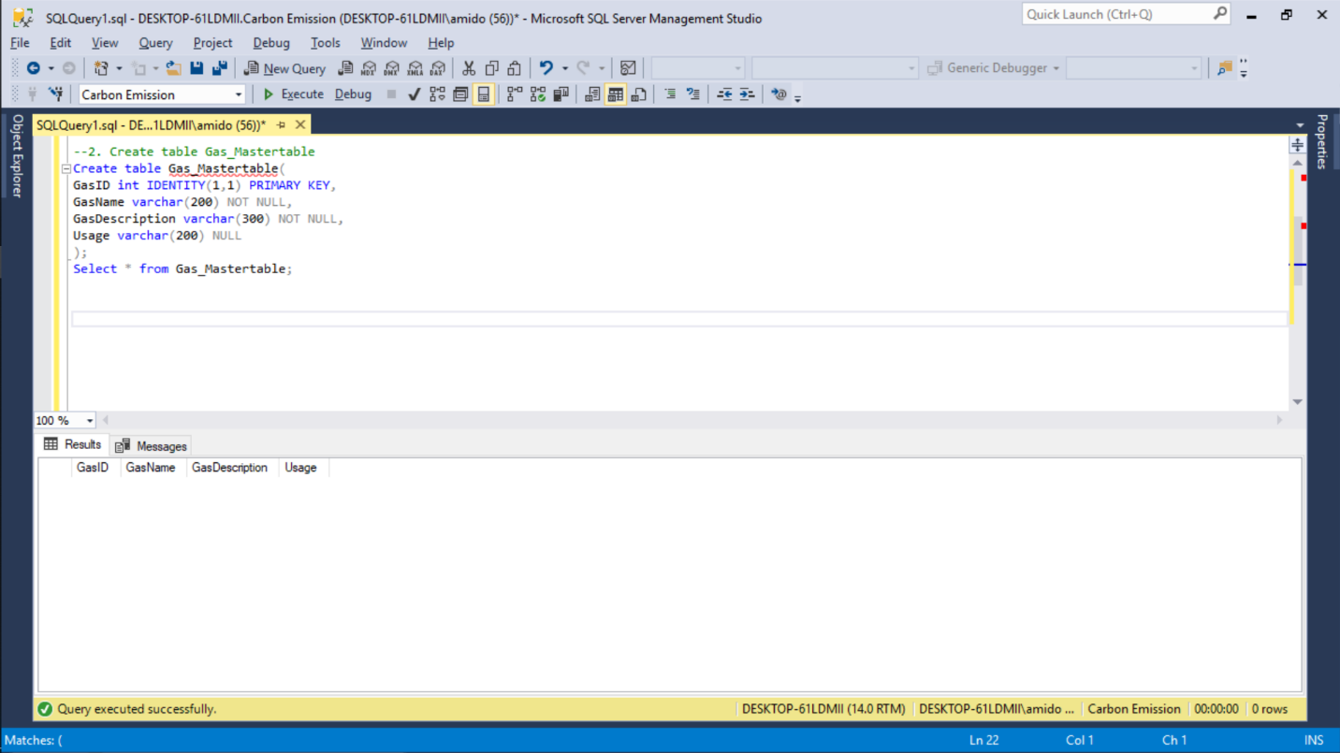

--3. Create Solution_MasterTable

Create table Solution_MasterTable(

SolutionID int IDENTITY(1,1) PRIMARY KEY,

SolutionName varchar(200) NOT NULL,

Description varchar(200) NULL

);

Select * from Solution_MasterTable;

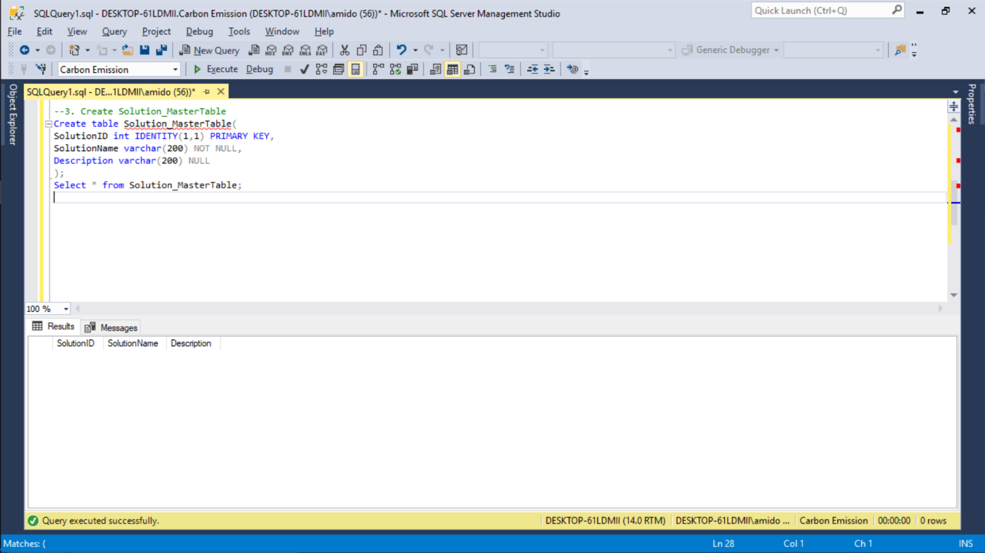

--first stage dependency

--4. Create table GasHazardLevel_MasterTable

Create table GasHazardLevel_MasterTable(

HazardID int NOT NULL,

GasID int NOT NULL,

SafePercentLevel int NULL,

HighPercentLevel int NULL,

CriticalPercentLevel int NULL,

CONSTRAINT GasHazardLevel_pk PRIMARY KEY (HazardID, GasID),

CONSTRAINT GasHazardLevel_fk FOREIGN KEY (GasID) references Gas_MasterTable(GasID)

);

Select * from GasHazardLevel_MasterTable;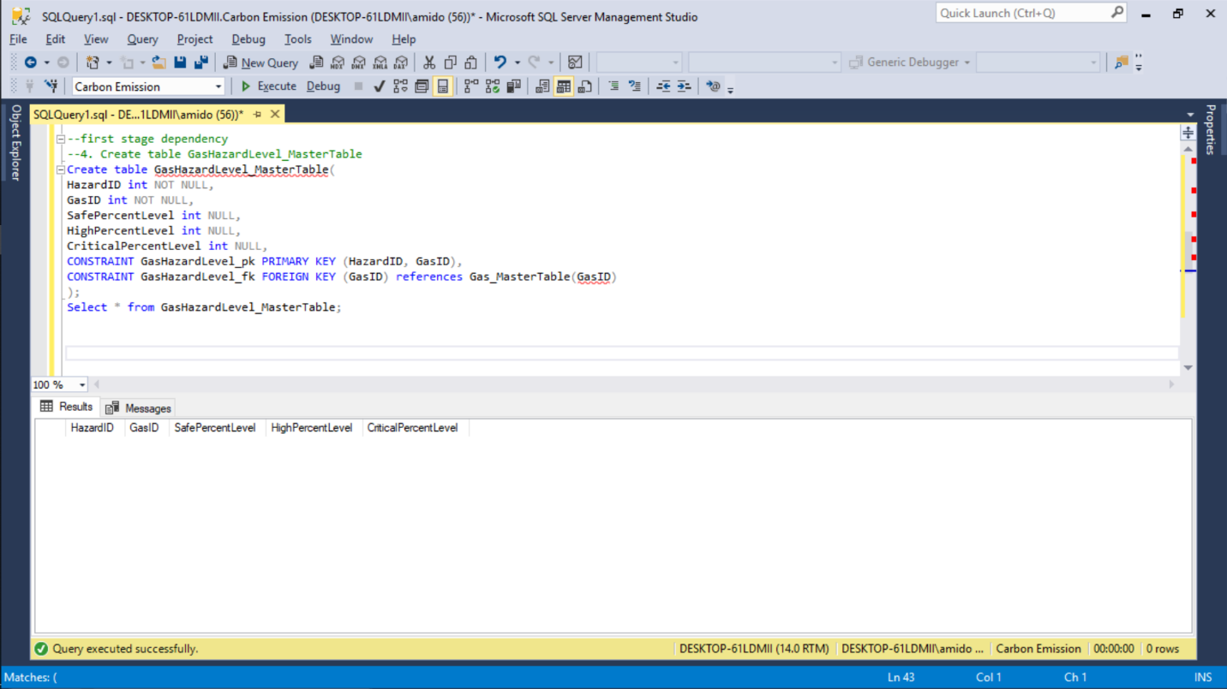

--5. Creating CountryGasEffect Table

Create table CountryGasEffects(

CGE_ID int NOT NULL,

CountryID int NOT NULL,

GasID int NOT NULL,

AirQuality varchar(50) NOT NULL,

GasPercentage int NULL,

GasEmittedByIndustry varchar(10) NULL,

GasEmittedByAgriculture varchar(10) NULL,

GasEmittedByHousehold varchar(10) NULL,

YearOfRecord int NOT NULL,

HazardLevel varchar(10) NOT NULL,

CHECK (HazardLevel in ('Low','Medium','High' )),

CONSTRAINT CountryGasEffects_pk PRIMARY KEY (CGE_ID),

CONSTRAINT CountryGasEffects_fk1 FOREIGN KEY (CountryID) references Country_MasterTable(CountryID),

CONSTRAINT CountryGasEffects_fk2 FOREIGN KEY (GasID) references Gas_MasterTable(GasID)

);

Select * from CountryGasEffects;

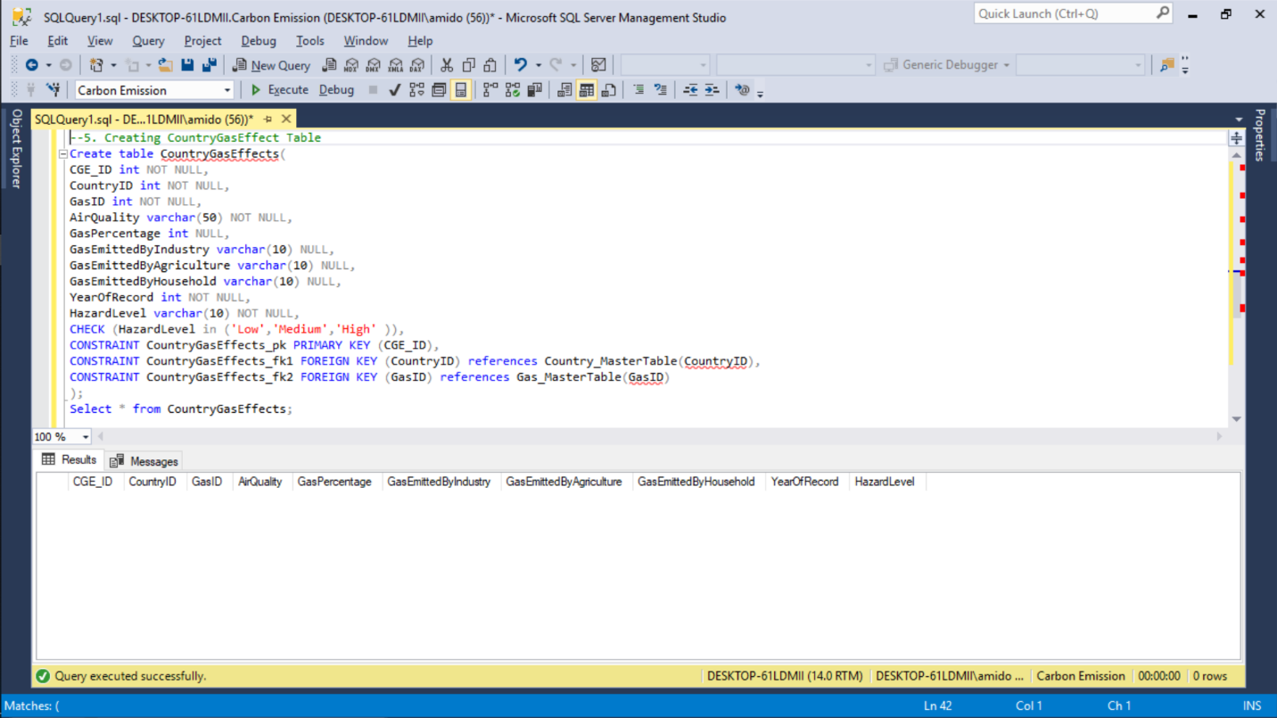

--6. Gas Effects

Create Table GasEffects(

GasEffectID int NOT NULL,

GasID int NOT NULL,

EffecName varchar(50) NOT NULL,

EffectDescription varchar(200) NULL,

PositiveOrNegativeEffect varchar(20) NOT NULL,

EffectsOnType varchar(100) NOT NULL,

CHECK (PositiveOrNegativeEffect in ('Positive', 'Negative')),

CONSTRAINT GasEffects_pk PRIMARY KEY (GasEffectID),

CONSTRAINT GasEffects_fk FOREIGN KEY (GasID) references Gas_MasterTable(GasID)

);

Select * from GasEffects; 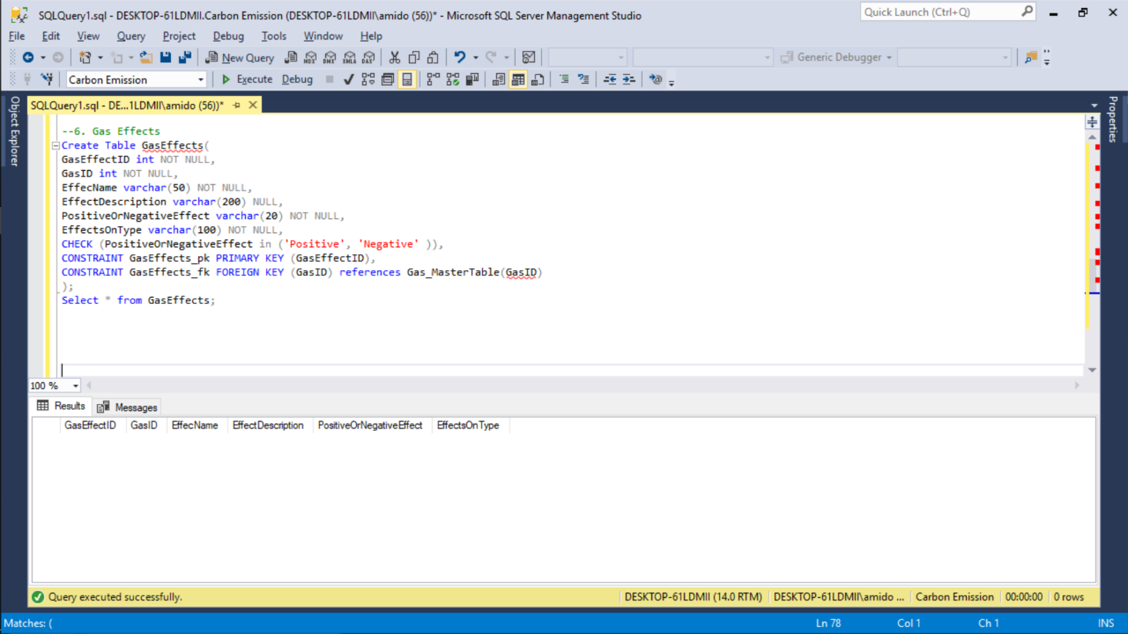

--7. Solution for Effects

Create Table SolutionForEffects(

SEID int NOT NULL,

SolutionID int NOT NULL,

GasEffectID int NOT NULL,

EffectOnType varchar(50) NULL,

CONSTRAINT SolutionForEffects_pk PRIMARY KEY (SEID),

CONSTRAINT SolutionForEffects_fk1 FOREIGN KEY (SolutionID) references Solution_MasterTable(SolutionID),

CONSTRAINT SolutionForEffects_fk2 FOREIGN KEY (GasEffectID) references GasEffects(GasEffectID)

);

Select * from SolutionForEffects;

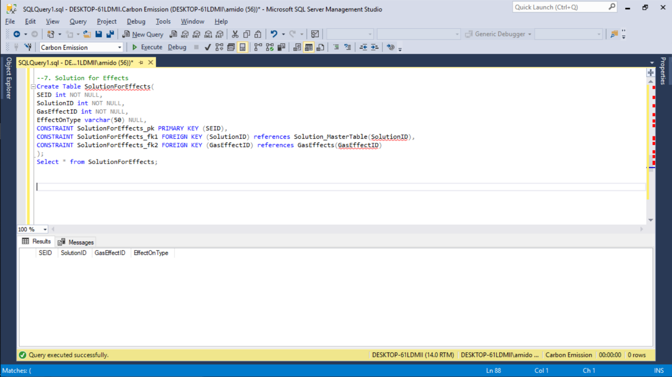

--8. Environment Effects

Create table EnvironmentEffect(

GasEffectID int NOT NULL,

CountryID int NOT NULL,

LevelChange varchar(10) NOT NULL,

CONSTRAINT EnvironmentEffect_pk PRIMARY KEY (GasEffectID, CountryID),

CONSTRAINT EnvironmentEffect_fk1 FOREIGN KEY (GasEffectID) references GasEffects(GasEffectID),

CONSTRAINT EnvironmentEffect_fk2 FOREIGN KEY (CountryID) references Country_MasterTable(CountryID)

);

Select * from EnvironmentEffect;

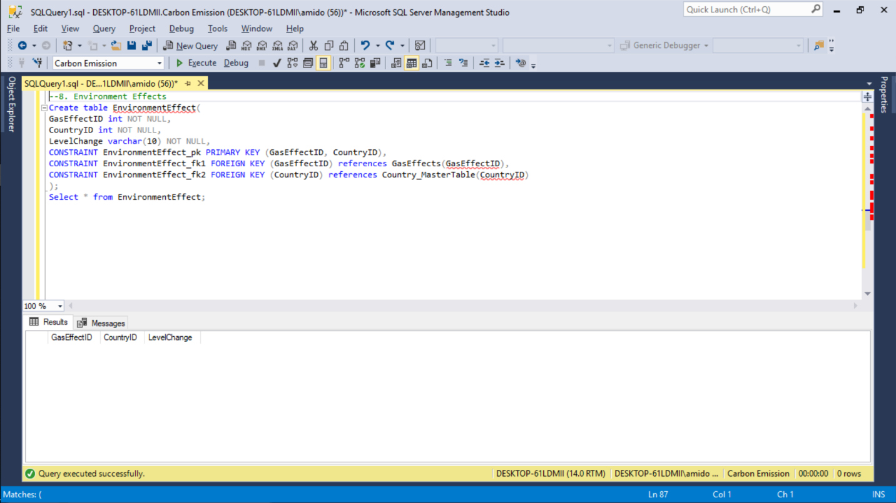

--9. Death

Create table Death(

GasEffectID int NOT NULL,

CountryID int NOT NULL,

DeathToll int NOT NULL,

CONSTRAINT Death_pk PRIMARY KEY (GasEffectID, CountryID),

CONSTRAINT Death_fk1 FOREIGN KEY (GasEffectID) references GasEffects(GasEffectID),

CONSTRAINT Death_fk2 FOREIGN KEY (CountryID) references Country_MasterTable(CountryID)

);

Select * from Death;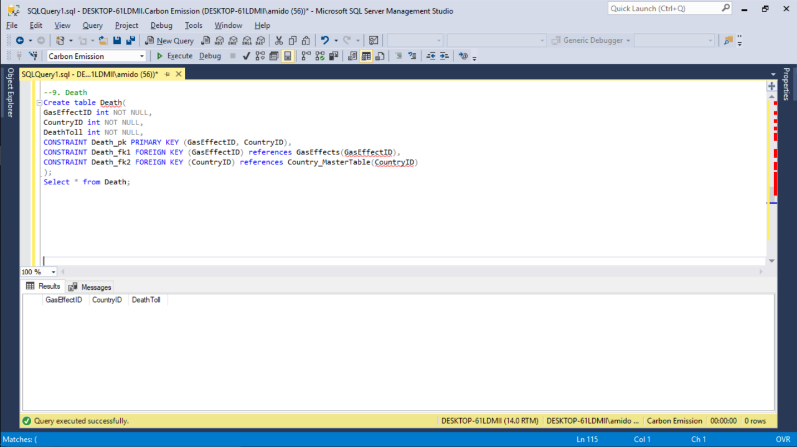

--10. Solution Implemented by country

--Second stage dependency

Create table SolutionImplementedByCountry(

SCID int NOT NULL,

SolutionID int NOT NULL,

CountryID int NOT NULL,

GasID int NOT NULL,

Year int NULL

CONSTRAINT SolutionImplementedByCountry_pk PRIMARY KEY (SCID),

CONSTRAINT SolutionImplementedByCountry_fk1 FOREIGN KEY (CountryID) references Country_MasterTable(CountryID),

CONSTRAINT SolutionImplementedByCountry_fk2 FOREIGN KEY (SolutionID) references Solution_MasterTable(SolutionID),

CONSTRAINT SolutionImplementedByCountry_fk3 FOREIGN KEY (GasID) references Gas_MasterTable(GasID)

);

Select * from SolutionImplementedByCountry; 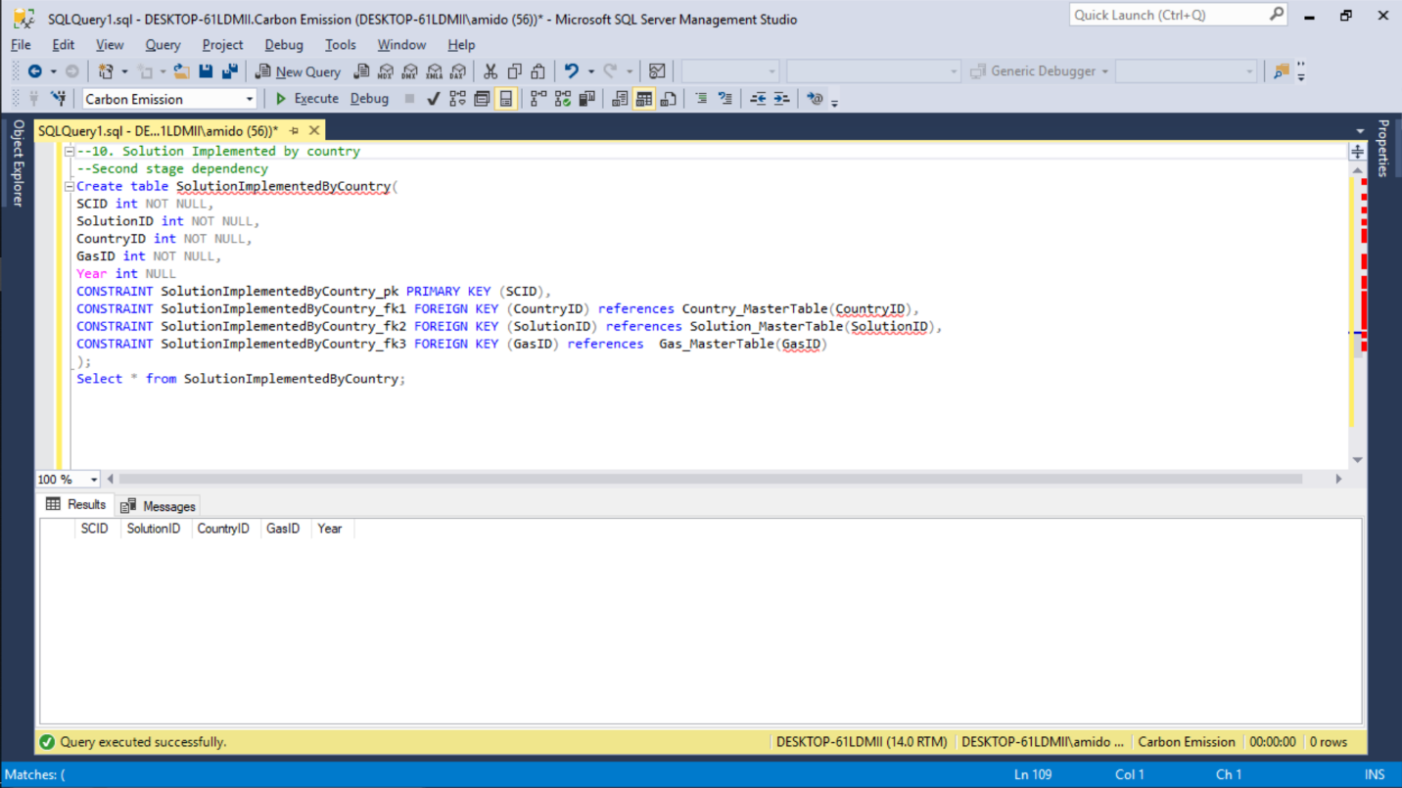

## Inserting Tables

--INSERT DATA--

--Country Master Table

INSERT INTO [dbo].[Country_MasterTable] VALUES('United States of America','North America',325.7,9.83,'United States Dollar')

INSERT INTO [dbo].[Country_MasterTable] VALUES('Russia','Asia',144.5,17.09,'Russian ruble')

INSERT INTO [dbo].[Country_MasterTable] VALUES('England','Europe',54.79,0.13,'Pound sterling')

INSERT INTO [dbo].[Country_MasterTable] VALUES('India','Asia',1339,3.286,'Rupee')

INSERT INTO [dbo].[Country_MasterTable] VALUES('China','Asia',1386,9.59,'Renminbi')

INSERT INTO [dbo].[Country_MasterTable] VALUES('France','Europe',67.12,0.64,'Euro')

INSERT INTO [dbo].[Country_MasterTable] VALUES('Japan','Asia',126.8,0.38,'Japanese yen')

INSERT INTO [dbo].[Country_MasterTable] VALUES('Italy','Europe',60.59,0.31,'Euro')

INSERT INTO [dbo].[Country_MasterTable] VALUES('Egypt','Africa',97.55,1.01,'Egyptian pound')

INSERT INTO [dbo].[Country_MasterTable] VALUES('Mexico','North America',129.2,1.97,'Mexican peso')

INSERT INTO [dbo].[Country_MasterTable] VALUES('Canada','North America',36.71,9.98,'Canadian dollar')

INSERT INTO [dbo].[Country_MasterTable] VALUES('United Arab Emirates','Asia', 9.4,0.08, 'United Arab Emirates dirham')

Select * from Country_MasterTable; 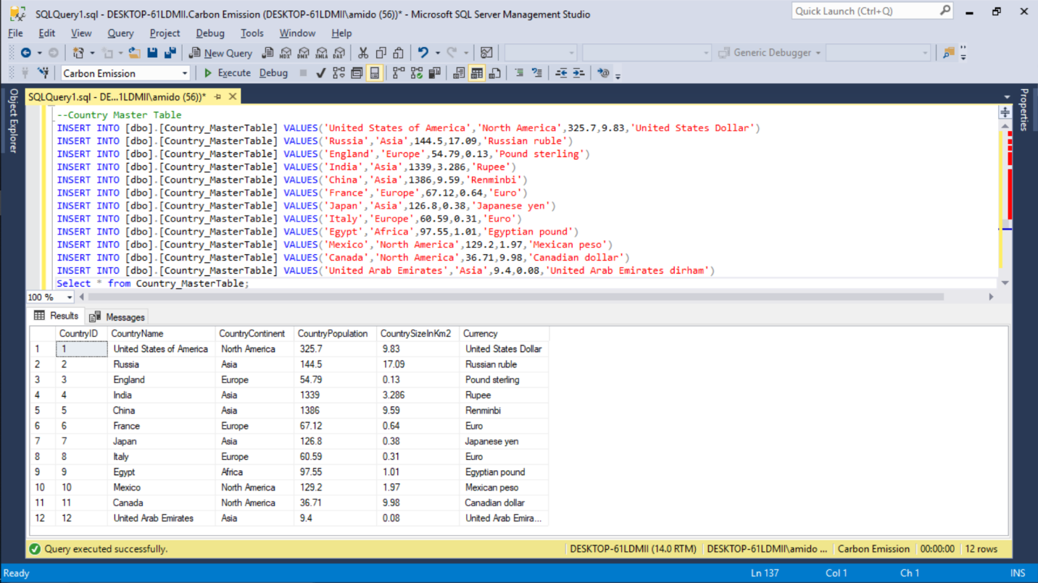

-- Gas Master Table

INSERT INTO [dbo].[Gas_Mastertable] VALUES('CO2','Carbon dioxide','Industry, Emission from Human Respiration')

INSERT INTO [dbo].[Gas_Mastertable] VALUES('CO','Carbon Monoxide','Industry, Emission from vehicles')

INSERT INTO [dbo].[Gas_Mastertable] VALUES('NO2','Nitrogen Dioxide','Rocket Fuel, Industry')

INSERT INTO [dbo].[Gas_Mastertable] VALUES('SO2','Sulphur Dioxide','Preservative, Pest control')

INSERT INTO [dbo].[Gas_Mastertable] VALUES('CFCs','Chlorofluorocarbons','Air conditioning, HVAC, Refridgerators')

Select * from Gas_MasterTable;

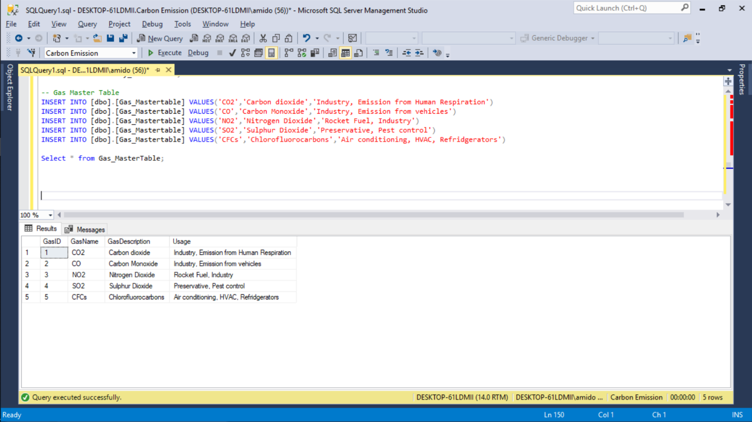

--Solution master

INSERT INTO [dbo].[Solution_MasterTable] VALUES('Air Purifiers','Industrial Level Air purifiers')

INSERT INTO [dbo].[Solution_MasterTable] VALUES('Aforestation','Planting more tries on a large scale')

INSERT INTO [dbo].[Solution_MasterTable] VALUES('Wind Mills','To convert wind energy to electric power')

INSERT INTO [dbo].[Solution_MasterTable] VALUES('Improvement in HVAC systems','To reduce CFC production by the HVAC units')

INSERT INTO [dbo].[Solution_MasterTable] VALUES('Solar Power','To convert Solar energy to heat and electric power')

INSERT INTO [dbo].[Solution_MasterTable] VALUES('Traffic Reduction','Make policies to decrease the traffic on Roads')

INSERT INTO [dbo].[Solution_MasterTable] VALUES('Rules for Polluting Vehicles','To not allow highly polluting vehicles on the road')

INSERT INTO [dbo].[Solution_MasterTable] VALUES('Investment in Lower Emissions','Investment in projects that will help develop low emission solutions')

INSERT INTO [dbo].[Solution_MasterTable] VALUES('Investment in Renewable Energy','Investment in development and use of renewable energy')

INSERT INTO [dbo].[Solution_MasterTable] VALUES('Green Projects','Projects that take no or very low amount of non-renewable materials')

Select * from Solution_MasterTable;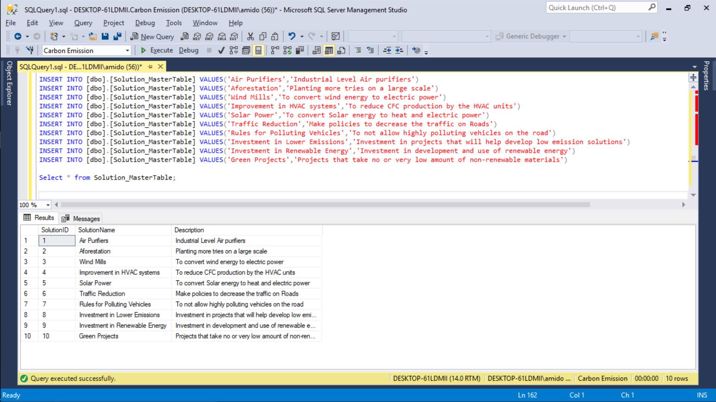

--Gas Hazard level

INSERT INTO [dbo].[GasHazardLevel_MasterTable] VALUES(1,1,1000,2000,5000)

INSERT INTO [dbo].[GasHazardLevel_MasterTable] VALUES(2,2,9,35,200)

INSERT INTO [dbo].[GasHazardLevel_MasterTable] VALUES(3,3,75,150,250)

INSERT INTO [dbo].[GasHazardLevel_MasterTable] VALUES(4,4,1,5,20)

INSERT INTO [dbo].[GasHazardLevel_MasterTable] VALUES(5,5,NULL,NULL,NULL)

Select * from GasHazardLevel_MasterTable;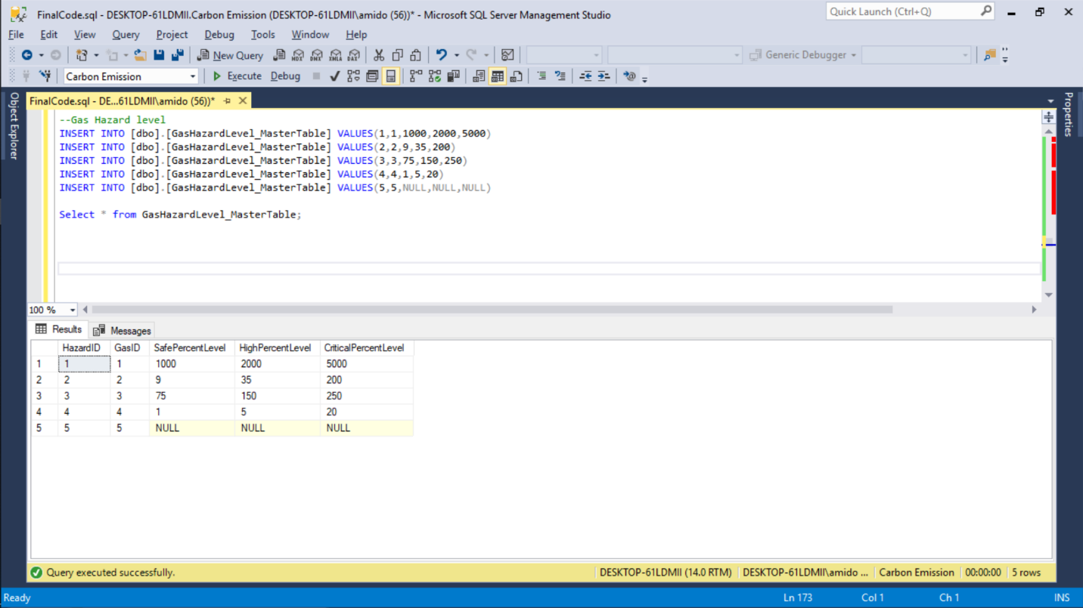

--Country Gas Effects

INSERT INTO [dbo].[CountryGasEffects] VALUES(1,1,1,'Good',800,'Yes','No','No',2010,'Low')

INSERT INTO [dbo].[CountryGasEffects] VALUES(2,1,5,'Good',NULL,'Yes','Yes','Yes',2018,'Medium')

INSERT INTO [dbo].[CountryGasEffects] VALUES(3,2,1,'Good',900,'Yes','No','Yes',2017,'Low')

INSERT INTO [dbo].[CountryGasEffects] VALUES(4,3,2,'Moderate',11,'Yes','No','Yes',2012,'High')

INSERT INTO [dbo].[CountryGasEffects] VALUES(5,3,3,'Moderate',70,'Yes','Yes','No',2009,'Medium')

INSERT INTO [dbo].[CountryGasEffects] VALUES(6,4,2,'Very Unhealthy',40,'Yes','Yes','No',2012,'High')

INSERT INTO [dbo].[CountryGasEffects] VALUES(7,4,4,'Very Unhealthy',5,'Yes','Yes','No',2010,'High')

INSERT INTO [dbo].[CountryGasEffects] VALUES(8,4,5,'Very Unhealthy',Null,'Yes','No','Yes',2018,'Medium')

INSERT INTO [dbo].[CountryGasEffects] VALUES(9,5,1,'Very Unhealthy',1100,'Yes','No','No',2010,'High')

INSERT INTO [dbo].[CountryGasEffects] VALUES(10,5,2,'Very Unhealthy',20,'Yes','No','Yes',2012,'High')

INSERT INTO [dbo].[CountryGasEffects] VALUES(11,5,4,'Very Unhealthy',6,'Yes','Yes','No',2010,'Medium')

INSERT INTO [dbo].[CountryGasEffects] VALUES(12,6,2,'Moderate',10,'Yes','No','Yes',2012,'High')

INSERT INTO [dbo].[CountryGasEffects] VALUES(13,6,5,'Moderate',Null,'Yes','No','Yes',2018,'Medium')

INSERT INTO [dbo].[CountryGasEffects] VALUES(14,7,1,'Moderate',900,'Yes','No','No',2010,'Medium')

INSERT INTO [dbo].[CountryGasEffects] VALUES(15,7,4,'Moderate',4,'Yes','Yes','No',2010,'Medium')

INSERT INTO [dbo].[CountryGasEffects] VALUES(16,8,1,'Moderate',700,'Yes','No','No',2010,'Low')

INSERT INTO [dbo].[CountryGasEffects] VALUES(17,9,3,'Moderate',70,'No','Yes','No',2009,'Medium')

INSERT INTO [dbo].[CountryGasEffects] VALUES(18,10,3,'Moderate',85,'No','Yes','No',2009,'High')

INSERT INTO [dbo].[CountryGasEffects] VALUES(19,10,5,'Moderate',Null,'Yes','Yes','Yes',2018,'High')

INSERT INTO [dbo].[CountryGasEffects] VALUES(20,11,1,'Good',800,'Yes','No','No',2010,'Low')

INSERT INTO [dbo].[CountryGasEffects] VALUES(21,12,1,'Unhealthy',1200,'Yes','No','No',2010,'High')

INSERT INTO [dbo].[CountryGasEffects] VALUES(22,12,5,'Unhealthy',NULL,'Yes','No','Yes',2018,'High')

select * from CountryGasEffects;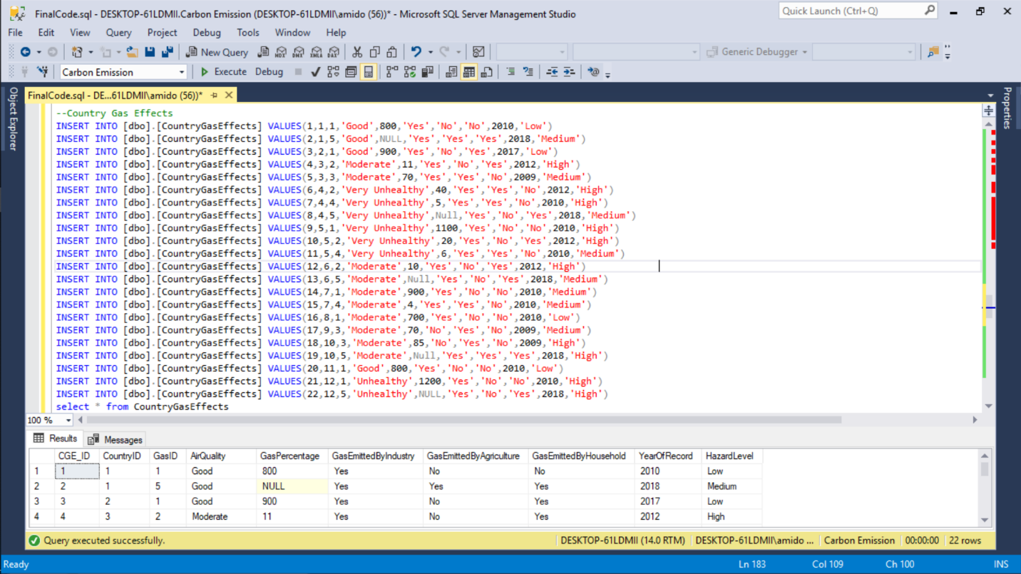

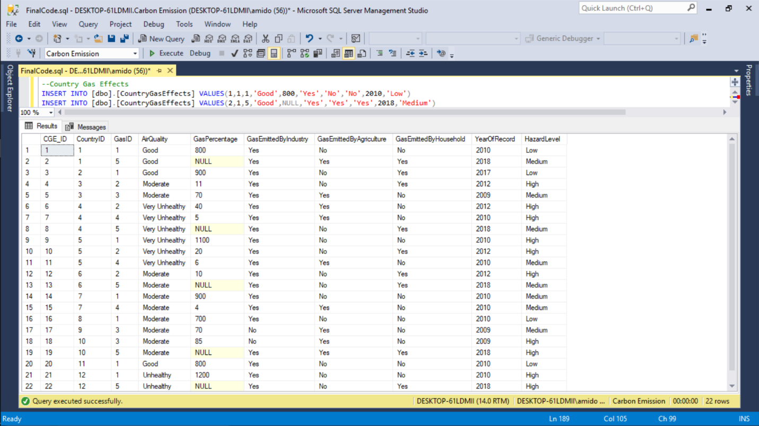

--Gas Effects

INSERT INTO [dbo].[GasEffects] VALUES(1,1,'Global Warming','Contributes to Greenhouse Effect','Negative','Whole Environment')

INSERT INTO [dbo].[GasEffects] VALUES(2,1,'Respiratory Problems','Due to effect on lungs','Negative','Humans and Animals')

INSERT INTO [dbo].[GasEffects] VALUES(3,2,'Poisoning','When in High Concentration','Negative','Humans and Animals')

INSERT INTO [dbo].[GasEffects] VALUES(4,2,'Heart Disease','Exposure over a long period of time','Negative','Humans')

INSERT INTO [dbo].[GasEffects] VALUES(5,3,'Respiratory Problems','Due to effect on lungs','Negative','Humans and Animals')

INSERT INTO [dbo].[GasEffects] VALUES(6,3,'Acid Rain','When present in high concentrations','Negative','Whole Environment')

INSERT INTO [dbo].[GasEffects] VALUES(7,4,'Respiratory Problems','Major cause of respiratory tract infection','Negative','Humans and Animals')

INSERT INTO [dbo].[GasEffects] VALUES(8,4,'Corrosion','Caused in buildings and structures','Negative','Whole Environment')

INSERT INTO [dbo].[GasEffects] VALUES(9,5,'Ozone Layer Depletion','Reacts with UV rays','Negative','Whole Environment')

INSERT INTO [dbo].[GasEffects] VALUES(10,5,'Skin Cancer','Indirect effect due to more UV exposure','Negative','Humans')

select * from GasEffects;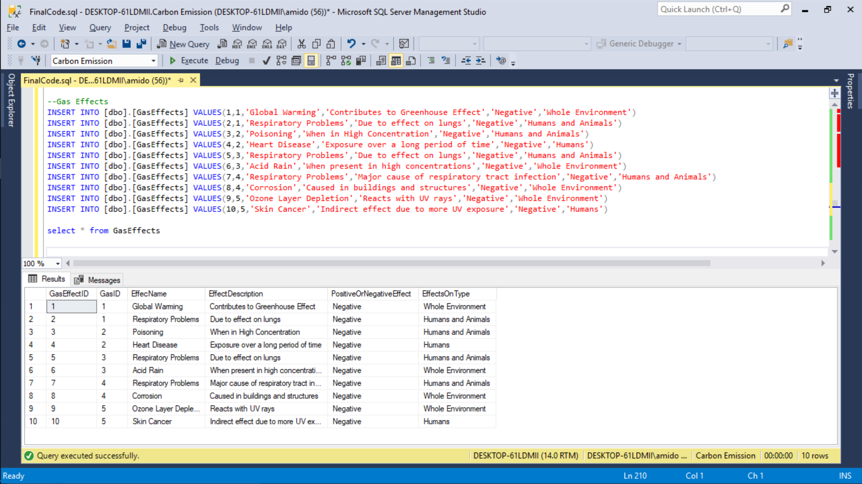

--Solution for effects

INSERT INTO [dbo].[SolutionForEffects] VALUES(1,2,1,'Whole Environment')

INSERT INTO [dbo].[SolutionForEffects] VALUES(2,3,2,'Humans and Animals')

INSERT INTO [dbo].[SolutionForEffects] VALUES(3,1,3,'Humans and Animals')

INSERT INTO [dbo].[SolutionForEffects] VALUES(4,5,4,'Humans')

INSERT INTO [dbo].[SolutionForEffects] VALUES(5,7,5,'Humans and Animals')

INSERT INTO [dbo].[SolutionForEffects] VALUES(6,6,6,'Whole Environment')

INSERT INTO [dbo].[SolutionForEffects] VALUES(7,10,7,'Humans and Animals')

INSERT INTO [dbo].[SolutionForEffects] VALUES(8,9,8,'Whole Environment')

INSERT INTO [dbo].[SolutionForEffects] VALUES(9,8,9,'Whole Environment')

INSERT INTO [dbo].[SolutionForEffects] VALUES(10,4,10,'Humans')

select * from SolutionForEffects;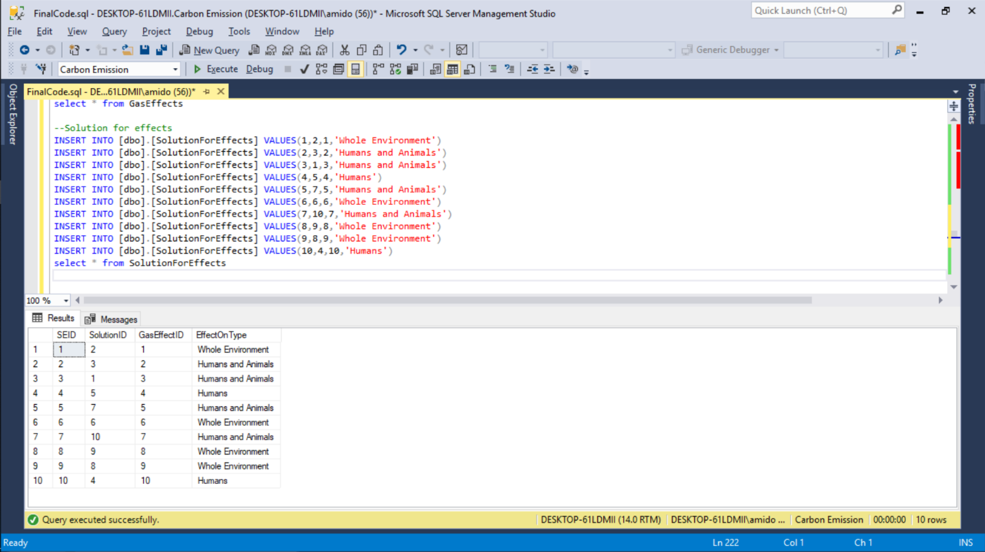

--Environment Effect

INSERT INTO [dbo].[EnvironmentEffect] VALUES(1,1,'Low')

INSERT INTO [dbo].[EnvironmentEffect] VALUES(9,1,'Low')

INSERT INTO [dbo].[EnvironmentEffect] VALUES(1,2,'Low')

INSERT INTO [dbo].[EnvironmentEffect] VALUES(6,3,'Medium')

INSERT INTO [dbo].[EnvironmentEffect] VALUES(8,4,'High')

INSERT INTO [dbo].[EnvironmentEffect] VALUES(9,4,'High')

INSERT INTO [dbo].[EnvironmentEffect] VALUES(1,5,'High')

INSERT INTO [dbo].[EnvironmentEffect] VALUES(8,5,'High')

INSERT INTO [dbo].[EnvironmentEffect] VALUES(9,6,'Medium')

INSERT INTO [dbo].[EnvironmentEffect] VALUES(1,7,'Medium')

INSERT INTO [dbo].[EnvironmentEffect] VALUES(8,7,'HIgh')

INSERT INTO [dbo].[EnvironmentEffect] VALUES(1,8,'Medium')

INSERT INTO [dbo].[EnvironmentEffect] VALUES(6,9,'Medium')

INSERT INTO [dbo].[EnvironmentEffect] VALUES(6,10,'High')

INSERT INTO [dbo].[EnvironmentEffect] VALUES(9,10,'Medium')

INSERT INTO [dbo].[EnvironmentEffect] VALUES(1,11,'Low')

INSERT INTO [dbo].[EnvironmentEffect] VALUES(1,12,'High')

INSERT INTO [dbo].[EnvironmentEffect] VALUES(9,12,'High')

INSERT INTO [dbo].[EnvironmentEffect] VALUES(1,12,'High')

INSERT INTO [dbo].[EnvironmentEffect] VALUES(9,12,'High')

select * from EnvironmentEffect;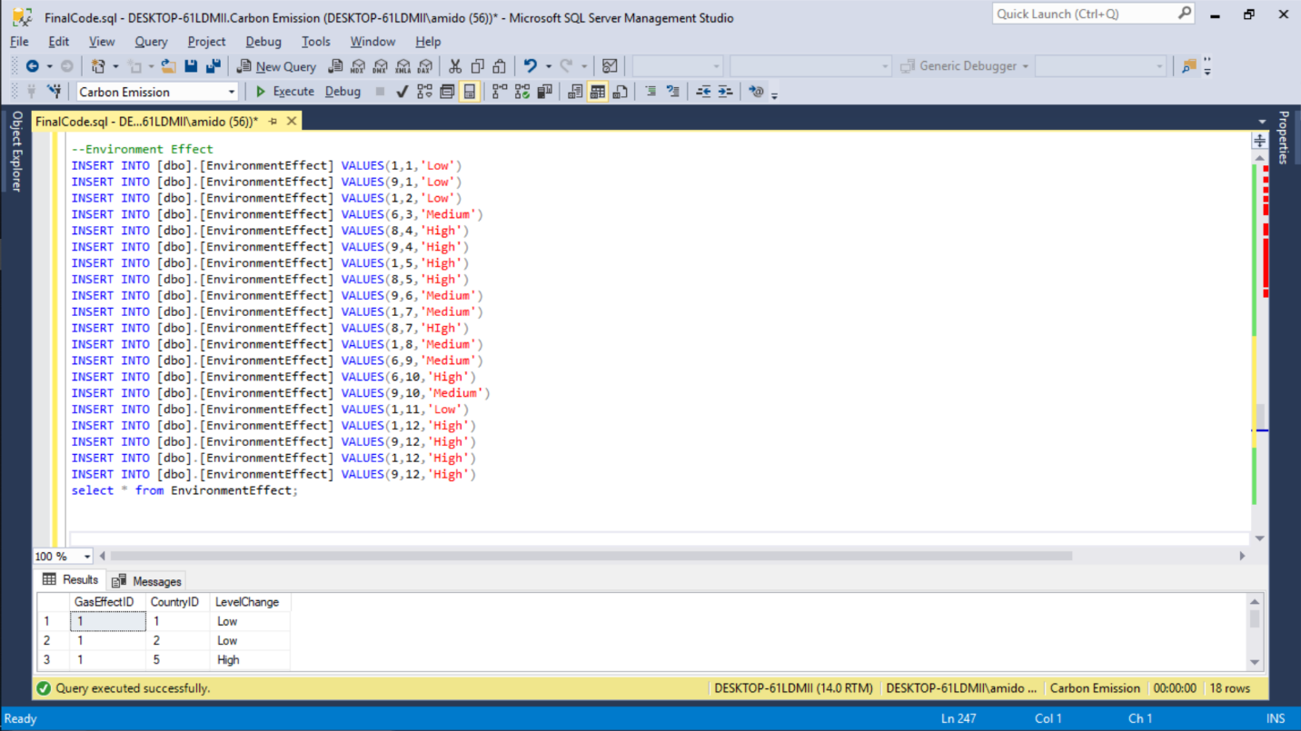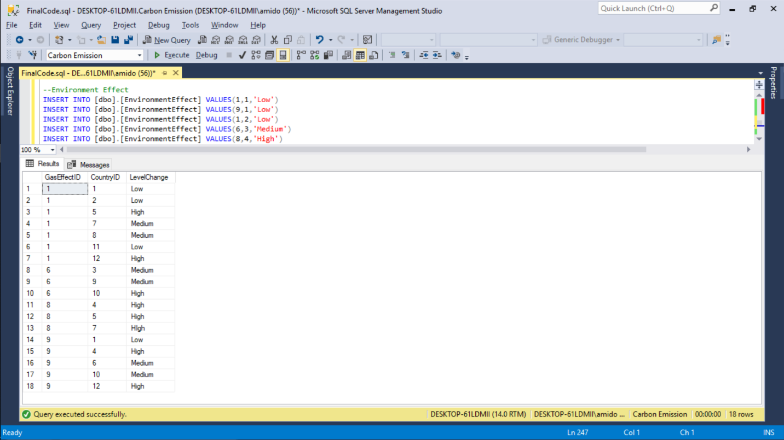

--Death

INSERT INTO [dbo].[Death] VALUES(2,1,586)

INSERT INTO [dbo].[Death] VALUES(10,1,134)

INSERT INTO [dbo].[Death] VALUES(2,2,643)

INSERT INTO [dbo].[Death] VALUES(3,3,74)

INSERT INTO [dbo].[Death] VALUES(5,3,354)

INSERT INTO [dbo].[Death] VALUES(3,4,267)

INSERT INTO [dbo].[Death] VALUES(7,4,919)

INSERT INTO [dbo].[Death] VALUES(10,4,208)

INSERT INTO [dbo].[Death] VALUES(2,5,856)

INSERT INTO [dbo].[Death] VALUES(3,5,157)

INSERT INTO [dbo].[Death] VALUES(7,5,528)

INSERT INTO [dbo].[Death] VALUES(3,6,81)

INSERT INTO [dbo].[Death] VALUES(10,6,35)

INSERT INTO [dbo].[Death] VALUES(2,7,309)

INSERT INTO [dbo].[Death] VALUES(7,7,421)

INSERT INTO [dbo].[Death] VALUES(2,8,358)

INSERT INTO [dbo].[Death] VALUES(5,9,532)

INSERT INTO [dbo].[Death] VALUES(5,10,619)

INSERT INTO [dbo].[Death] VALUES(10,10,197)

INSERT INTO [dbo].[Death] VALUES(2,11,128)

INSERT INTO [dbo].[Death] VALUES(2,12,321)

INSERT INTO [dbo].[Death] VALUES(10,12,145)

select * from Death;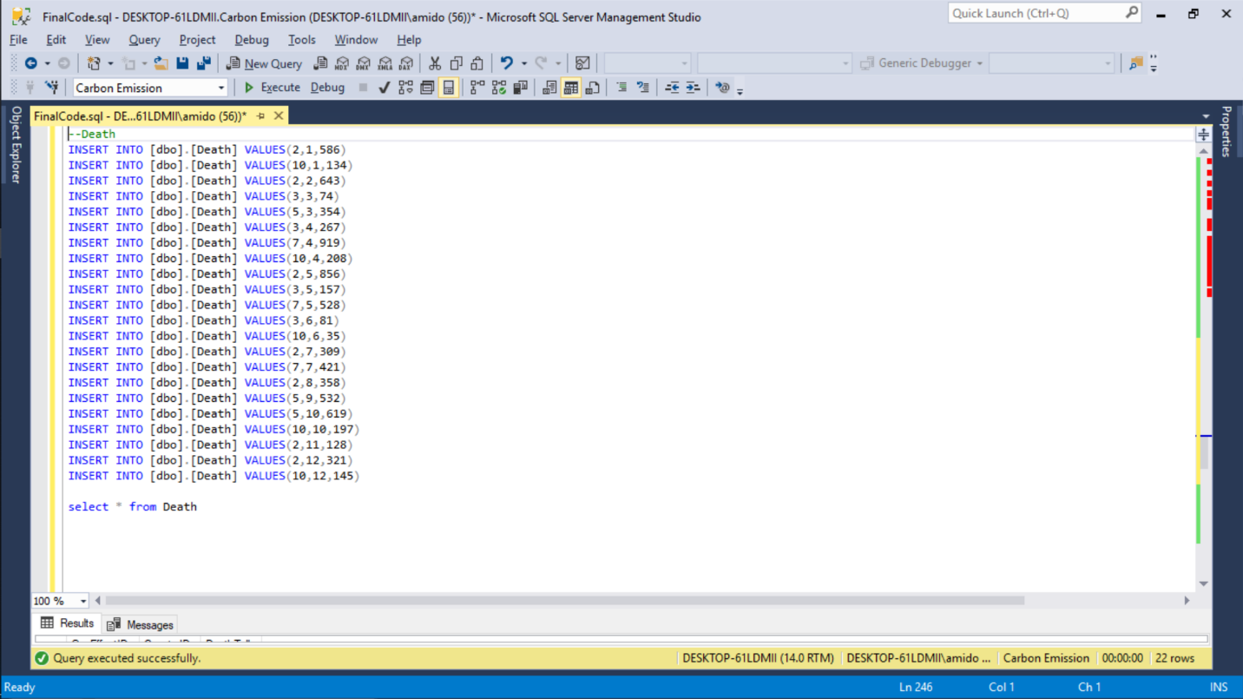

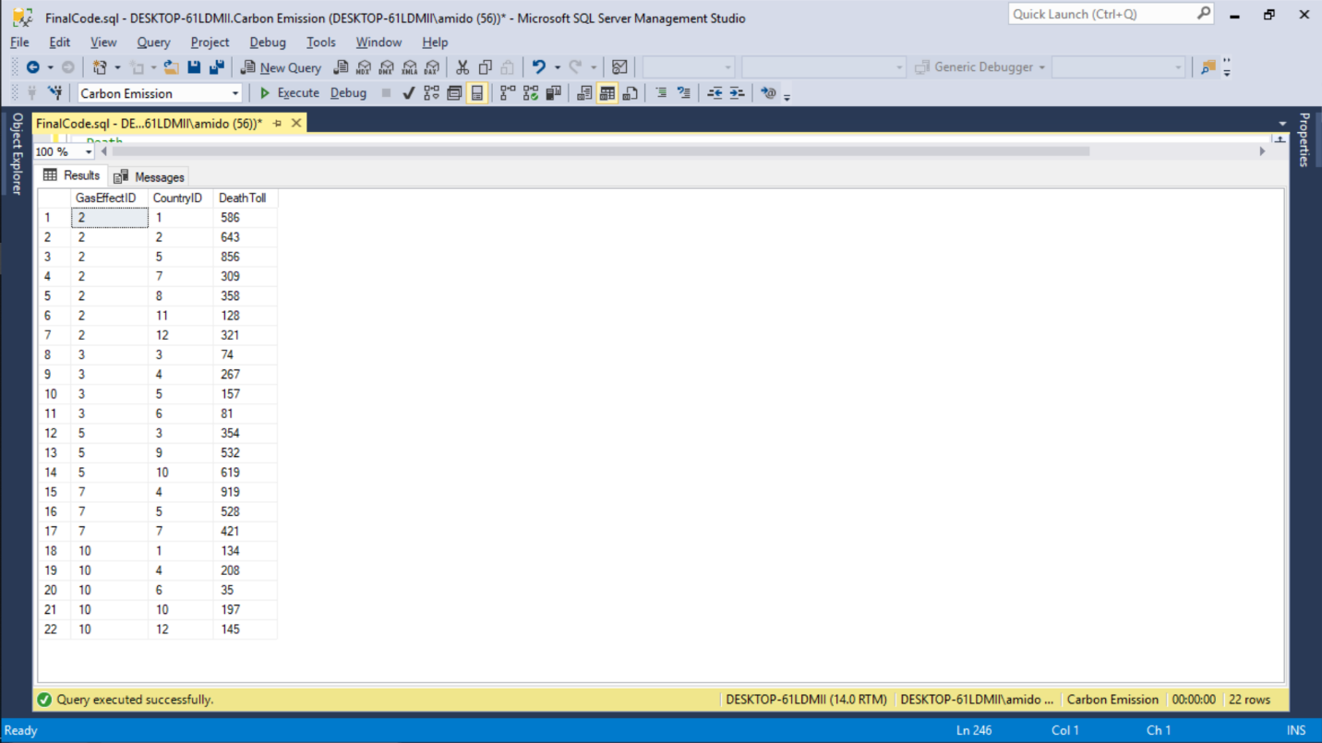

-- SolutionImplementedByCountry

INSERT INTO [dbo].[SolutionImplementedByCountry] VALUES(1,3,1,1,2012)

INSERT INTO [dbo].[SolutionImplementedByCountry] VALUES(2,4,1,5,2017)

INSERT INTO [dbo].[SolutionImplementedByCountry] VALUES(3,5,2,1,2016)

INSERT INTO [dbo].[SolutionImplementedByCountry] VALUES(4,5,3,2,2014)

INSERT INTO [dbo].[SolutionImplementedByCountry] VALUES(5,7,3,3,2013)

INSERT INTO [dbo].[SolutionImplementedByCountry] VALUES(6,2,4,2,2014)

INSERT INTO [dbo].[SolutionImplementedByCountry] VALUES(7,10,4,4,2015)

INSERT INTO [dbo].[SolutionImplementedByCountry] VALUES(8,4,4,5,2016)

INSERT INTO [dbo].[SolutionImplementedByCountry] VALUES(9,1,5,1,2018)

INSERT INTO [dbo].[SolutionImplementedByCountry] VALUES(10,2,5,2,2013)

INSERT INTO [dbo].[SolutionImplementedByCountry] VALUES(11,9,5,4,2014)

INSERT INTO [dbo].[SolutionImplementedByCountry] VALUES(12,3,6,2,2017)

INSERT INTO [dbo].[SolutionImplementedByCountry] VALUES(13,4,6,5,2015)

INSERT INTO [dbo].[SolutionImplementedByCountry] VALUES(14,2,7,1,2012)

INSERT INTO [dbo].[SolutionImplementedByCountry] VALUES(15,9,7,4,2014)

INSERT INTO [dbo].[SolutionImplementedByCountry] VALUES(16,2,8,1,2016)

INSERT INTO [dbo].[SolutionImplementedByCountry] VALUES(17,10,9,3,2013)

INSERT INTO [dbo].[SolutionImplementedByCountry] VALUES(18,5,10,3,2014)

INSERT INTO [dbo].[SolutionImplementedByCountry] VALUES(19,4,10,5,2017)

INSERT INTO [dbo].[SolutionImplementedByCountry] VALUES(20,3,11,1,2011)

INSERT INTO [dbo].[SolutionImplementedByCountry] VALUES(21,3,12,1,2014)

INSERT INTO [dbo].[SolutionImplementedByCountry] VALUES(22,4,12,5,2016)

select * from SolutionImplementedByCountry;

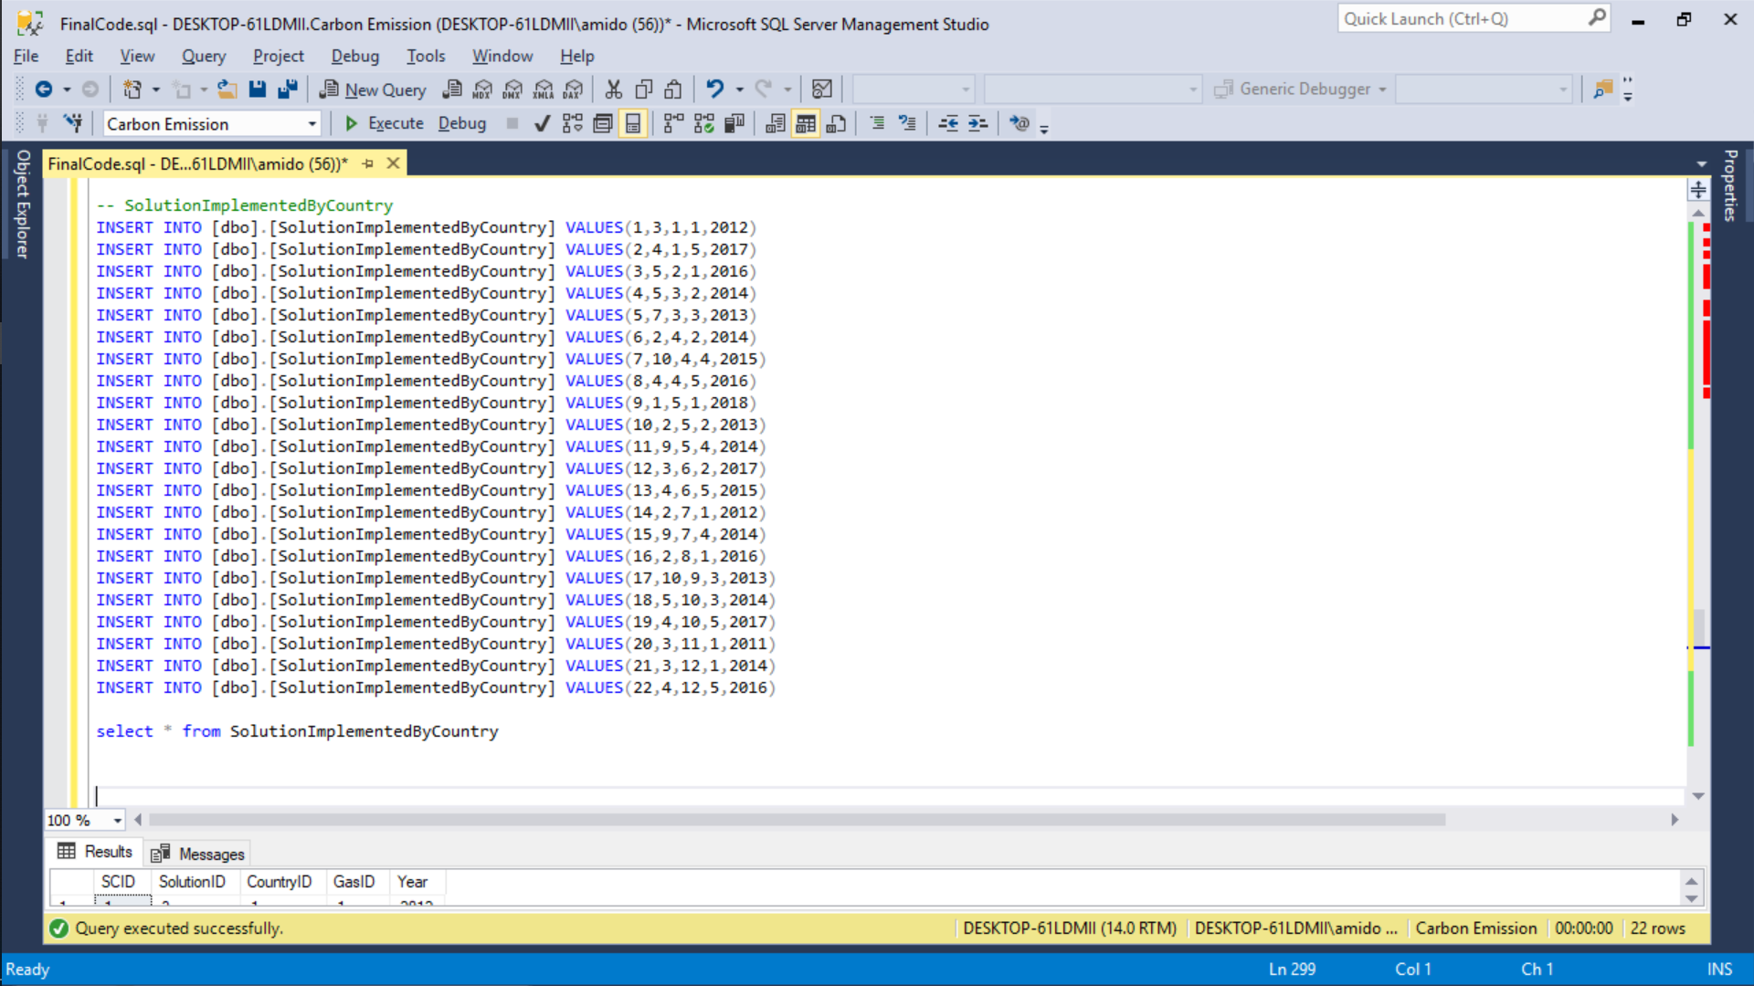

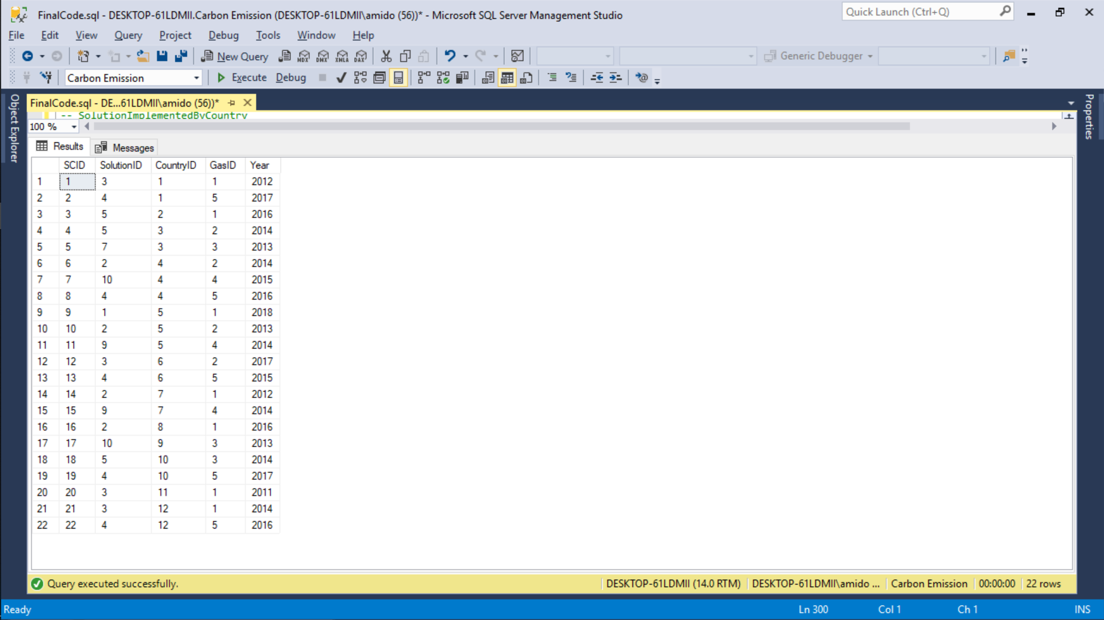

## Business Rules

1. All Co and CO2 levels will be measured in percentage
2. Only the Data collected over the span of last 10 years will be considered
3. Completed Database will be available for All to use for research purposes free of cost
4. Ozone layer depletion will be estimated on a global level and not for each country or region
5. Creators of the database have the right to determine which factors to include in the analysis
6. We are considering only the deaths clearly caused by one Gas effect (such as cancer), we will not consider deaths having multiple major causes (cancer + accident).
7. In the Gas Effect table, possible entries can only be “Glacier”, “Water level”, “Temperature”, “Animal”, “Human”
8. Glaciers that do not come under a specific country have been deemed as out of the scope of this project. Hence they have been omitted from the database.
9. For the sake of simplicity, the scope of this project is only narrow enough to look at effects country-wise and not city-wise.

**5. Major Data Questions**

1. What are the countries having Carbon emissions beyond the “safe” level?

-------------------------------------------------------

-------------------------------------------------------

--What are the countries having harmful Gas emissions beyond the “safe” level?

SELECT distinct C.CountryID, C.CountryName, G.GasName,GH.SafePercentLevel ,CG.GasPercentage, CG.HazardLevel

FROM Country_MasterTable C

JOIN Countrygaseffects CG

On C.CountryID = CG.CountryID

JOIN GasHazardLevel_MasterTable GH

On CG.GasID = GH.GasID

JOIN Gas_Mastertable G

on G.GasID = GH.GasID

Where CG.GasPercentage > GH.SafePercentLevel

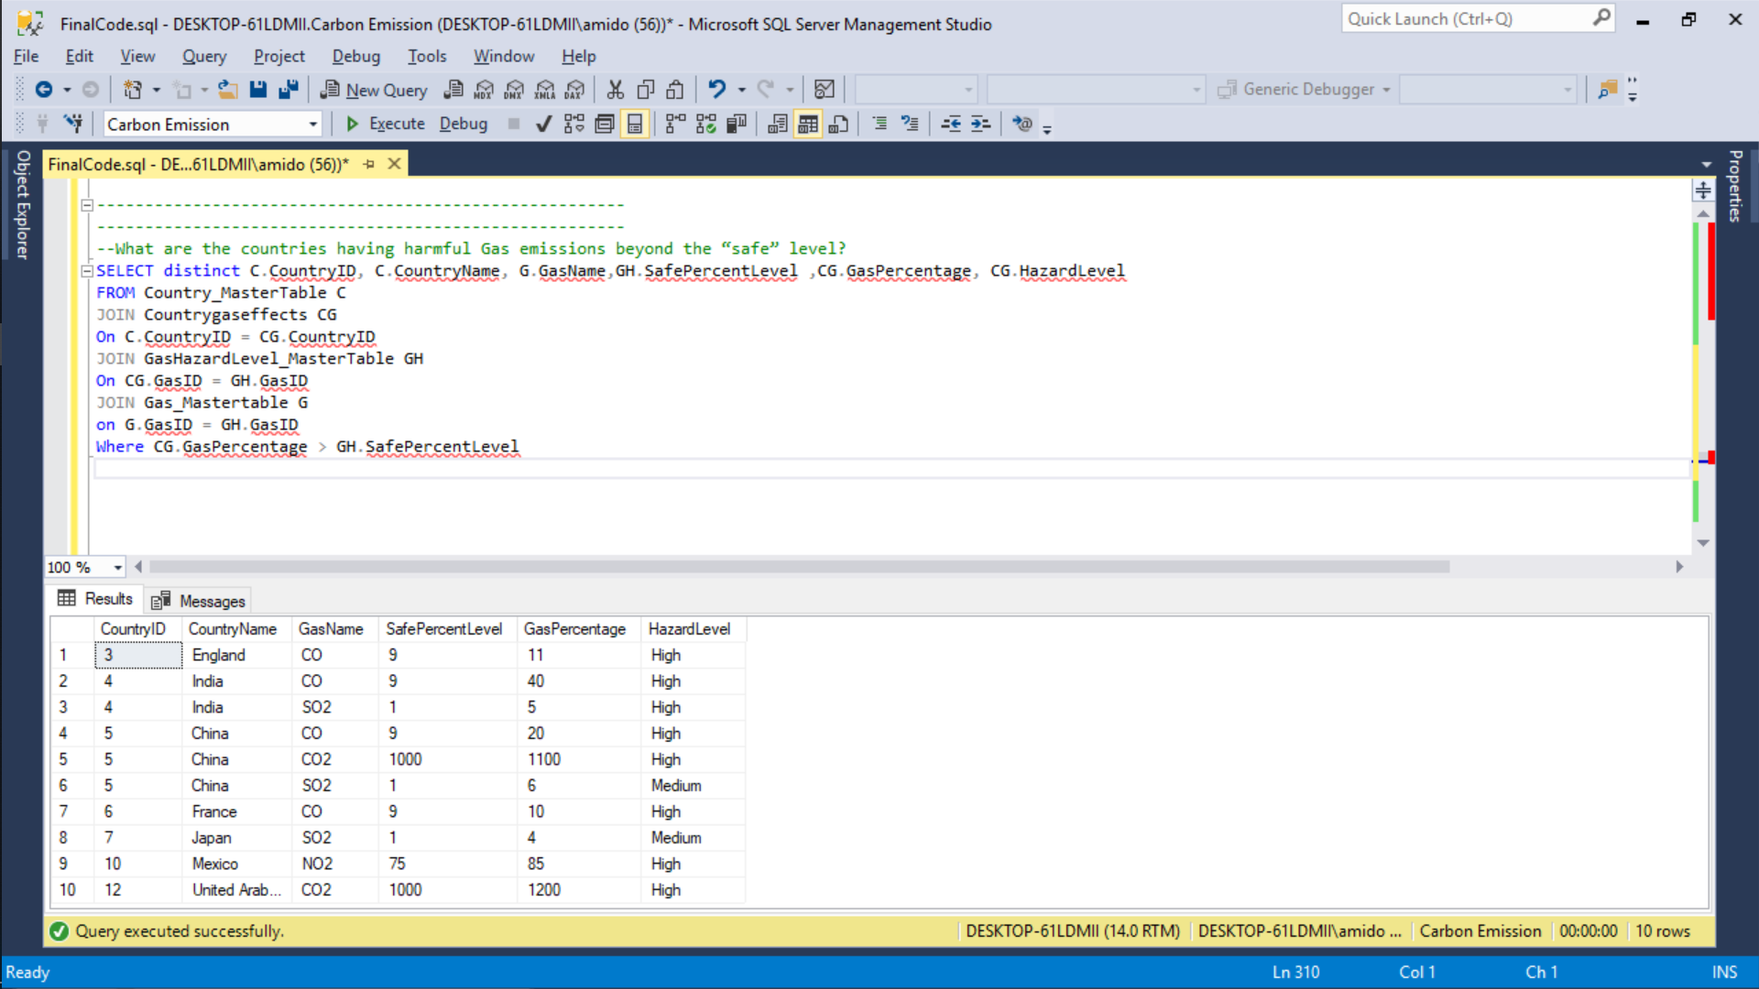

1. What are the safety measures (solutions) that countries with high carbon emissions are implementing?

--What are the safety measures (solutions) that countries with high harmful gas emissions are implementing?

Select distinct C.CountryName,C.CountryContinent,C.CountryPopulation, S.SolutionName, S.Description

from SolutionImplementedByCountry SC

JOIN CountryGasEffects CG

ON SC.CountryID = CG.CountryID

JOIN Solution_MasterTable S

ON S.SolutionID = SC.SolutionID

JOIN Country_MasterTable C

ON SC.CountryID = C.CountryID

Where HazardLevel = 'High'; 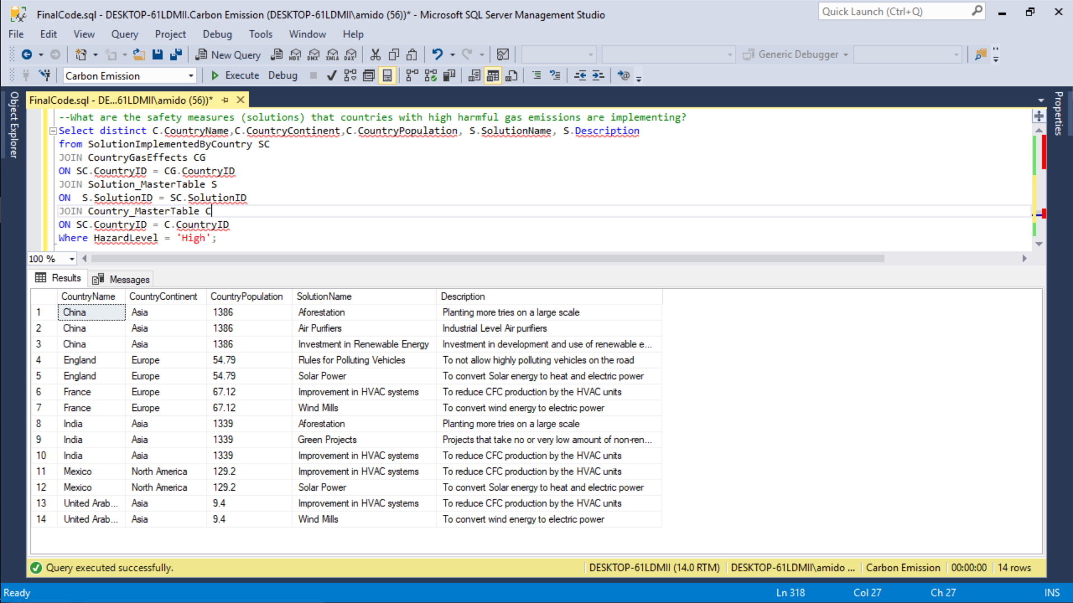

1. What are the safety measures that countries with Low carbon emissions are implementing?

--What are the safety measures that countries with Low carbon emissions are implementing?

Create View LowCarbonEmittingCountries

AS

Select distinct S.SolutionID,C.CountryName,C.CountryContinent,C.CountryPopulation, G.GasName,S.SolutionName, S.Description

from SolutionImplementedByCountry SC

JOIN CountryGasEffects CG

ON SC.CountryID = CG.CountryID

JOIN Solution_MasterTable S

ON S.SolutionID = SC.SolutionID

JOIN Country_MasterTable C

ON SC.CountryID = C.CountryID

JOIN Gas_Mastertable G

ON G.GasID = SC.GasID

Where HazardLevel = 'Low';

Select * from LowCarbonEmittingCountries;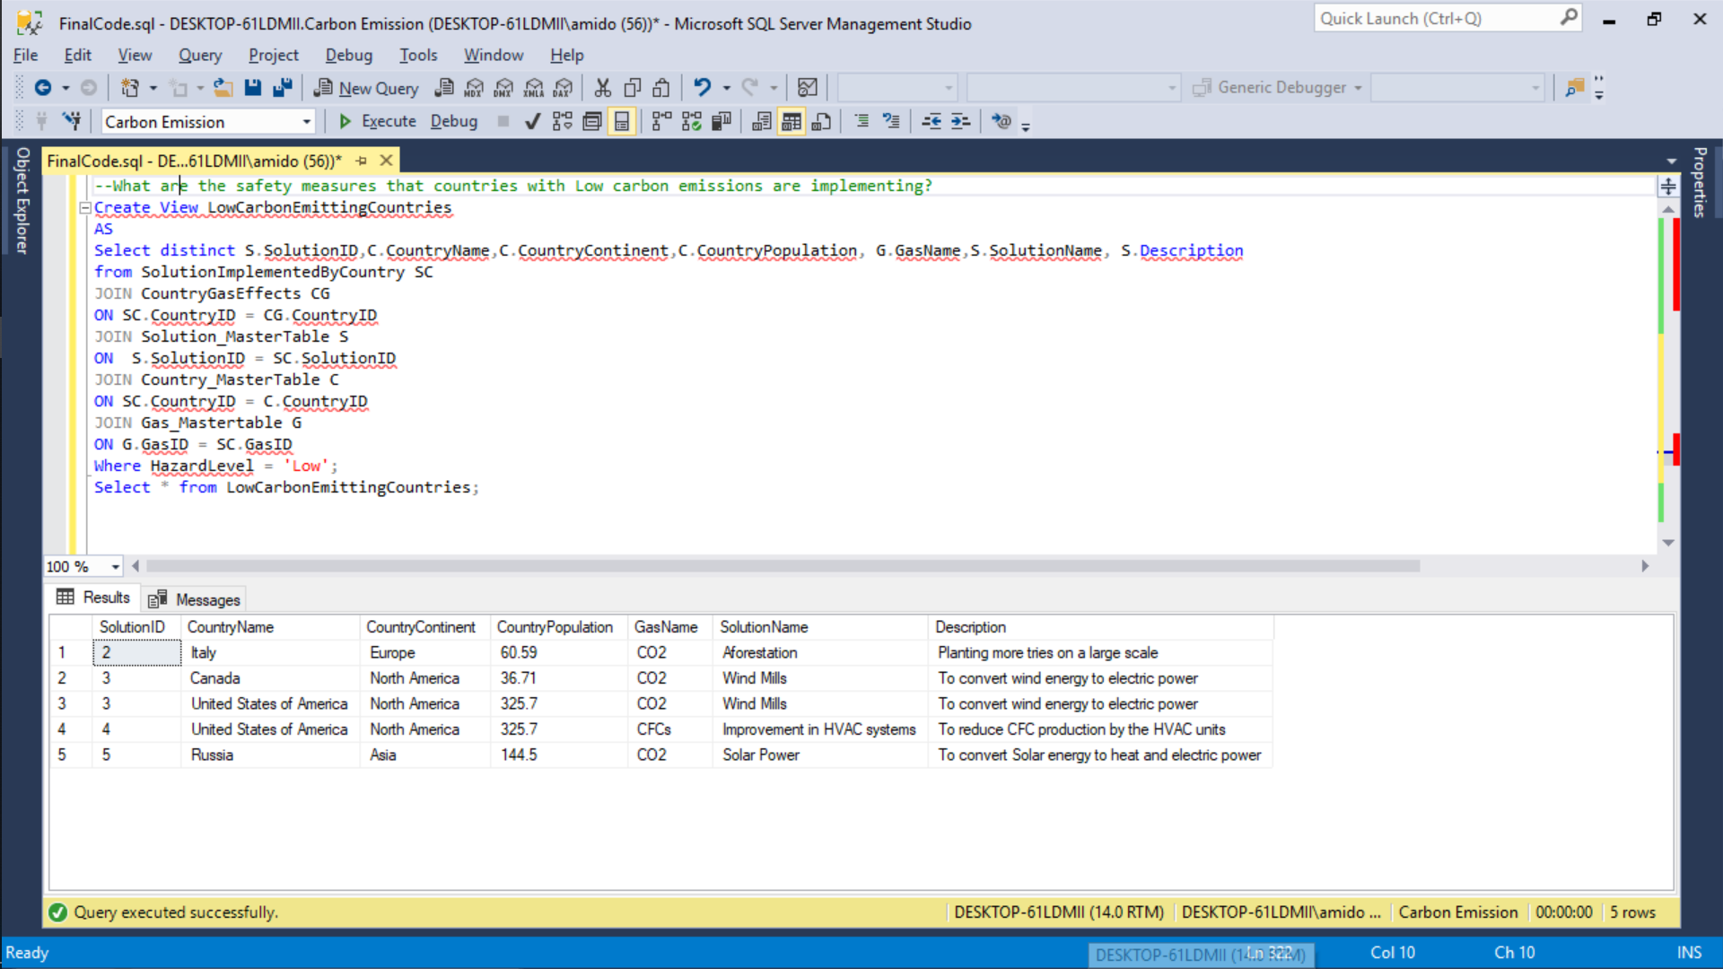

1. What are the safety measures that countries with high carbon emissions should implement in order to bring down their carbon emissions?

--What are the safety measures that countries with high carbon emissions should implement in order to bring down their carbon emissions?

--Answer: Countries with High emission should look at the solutions made by the countries with Low emission rate.

Select * from LowCarbonEmittingCountries;

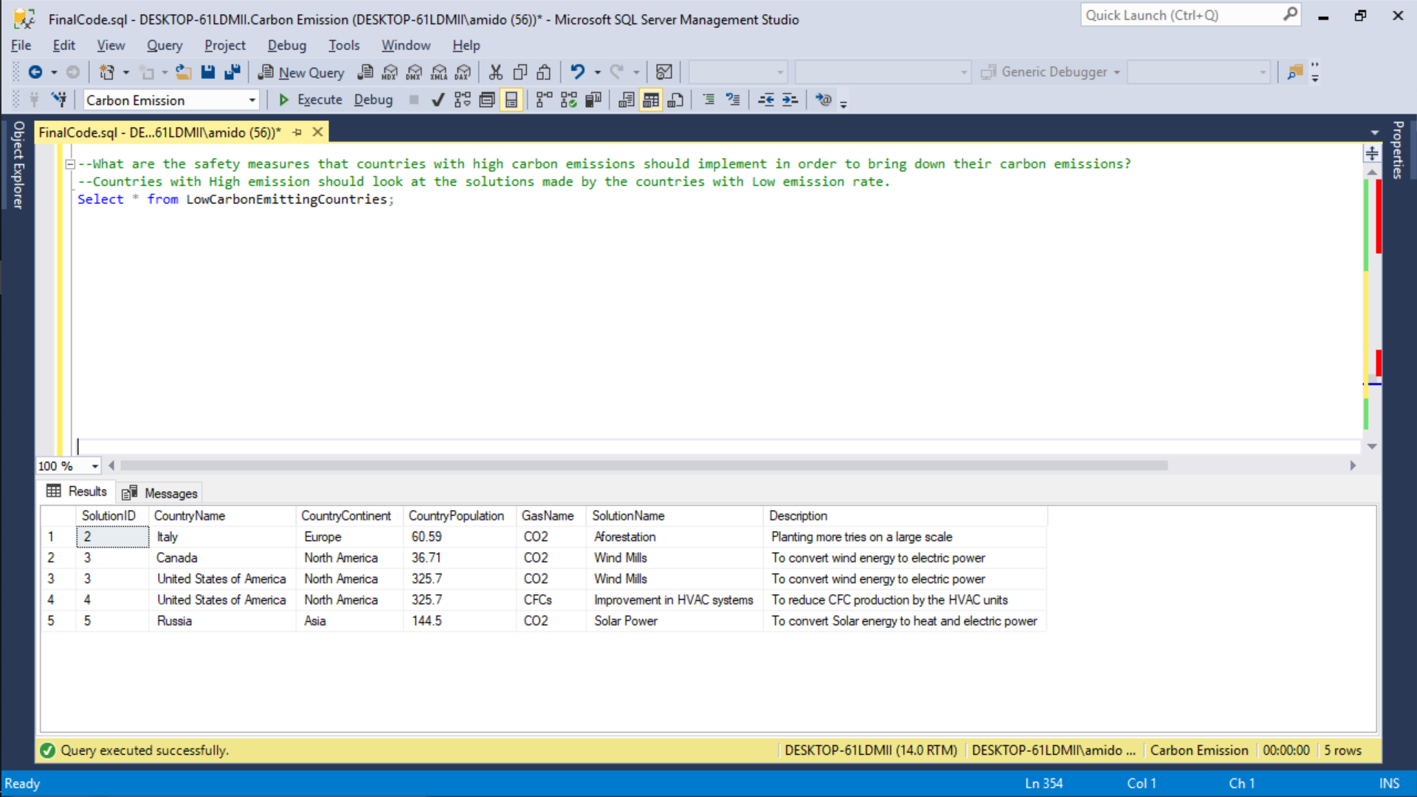

1. What are the environmental effects caused on a country due to carbon emissions?

--What are the environmental effects caused due to harmful gas emissions?

Create View EnvironmentalEffects

AS

Select G.GasID,G.GasName,G.GasDescription,G.Usage,GE.EffecName,GE.EffectDescription,GE.PositiveOrNegativeEffect,GE.GasEffectID from GasEffects GE

JOIN Gas_Mastertable G

ON GE.GasID = G.GasID

WHERE GE.EffectsOnType = 'Whole Environment';

Select * from EnvironmentalEffects;

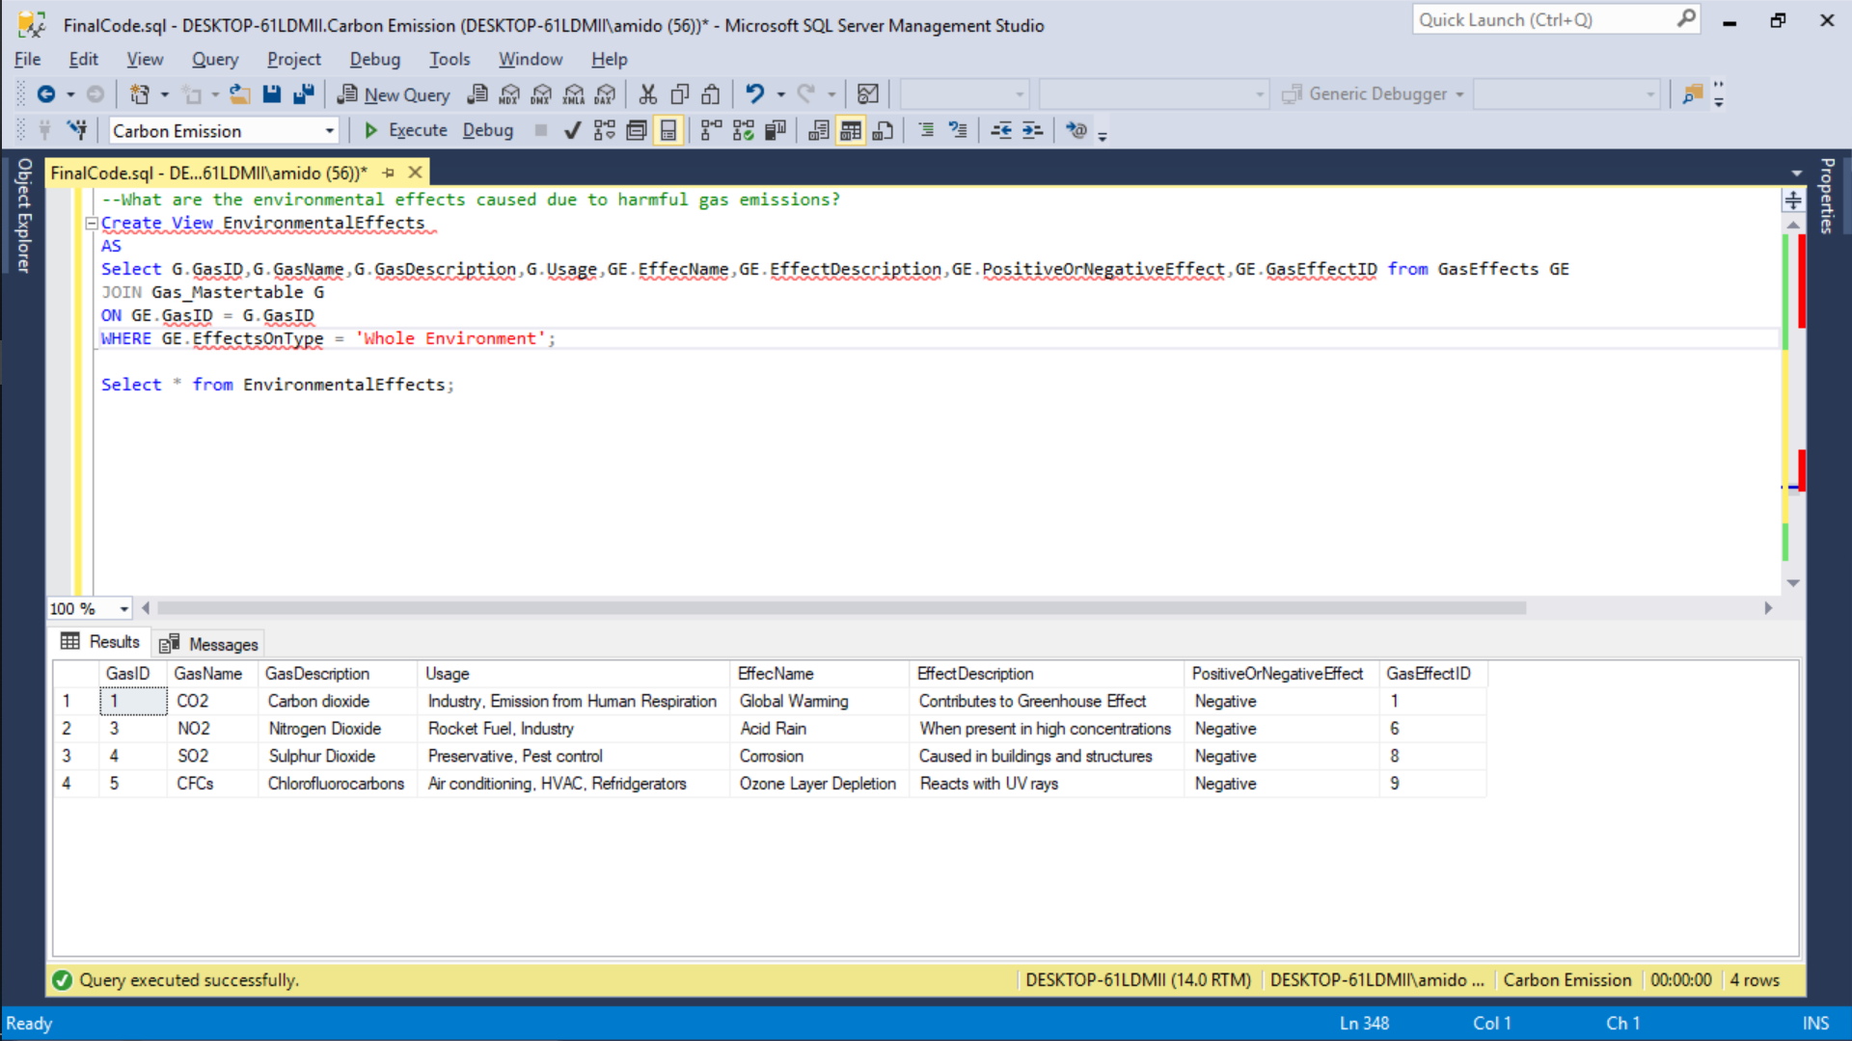

1. What is the death toll of each country with respect to the cause of death?

--What are the effects on Humans and Animals caused due to harmful gas emissions?

Select G.GasID,G.GasName,G.GasDescription,G.Usage,GE.EffecName,GE.EffectDescription,GE.PositiveOrNegativeEffect,GE.GasEffectID

from GasEffects GE

JOIN Gas_Mastertable G

ON GE.GasID = G.GasID

WHERE GE.EffectsOnType = 'Humans and Animals' or GE.EffectsOnType = 'Humans';

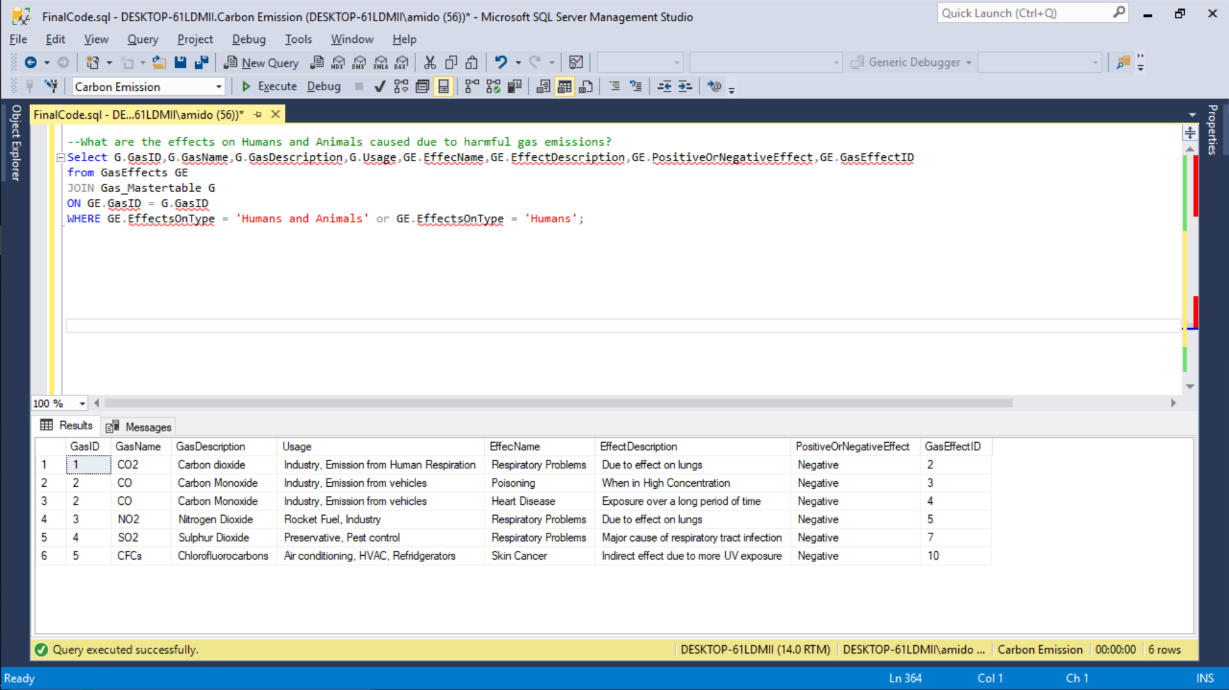

1. What are the individual carbon monoxide and carbon dioxide levels of each country?

--What is the death toll of each country with respect to the cause of death?

Select C.CountryName,C.CountryContinent, C.CountryPopulation, C.CountrySizeInKm2, D.DeathToll, Ga.GasName,G.EffecName, G.EffectDescription, G.PositiveOrNegativeEffect

from Country_MasterTable C

JOIN Death D

ON C.CountryID = D.CountryID

JOIN GasEffects G

ON D.GasEffectID = G.GasEffectID

Join Gas_Mastertable Ga

ON G.GasID = Ga.GasID

WHERE G.EffectsOnType= 'Humans and Animals' or G.EffectsOnType= 'Humans'

order by C.CountryName;

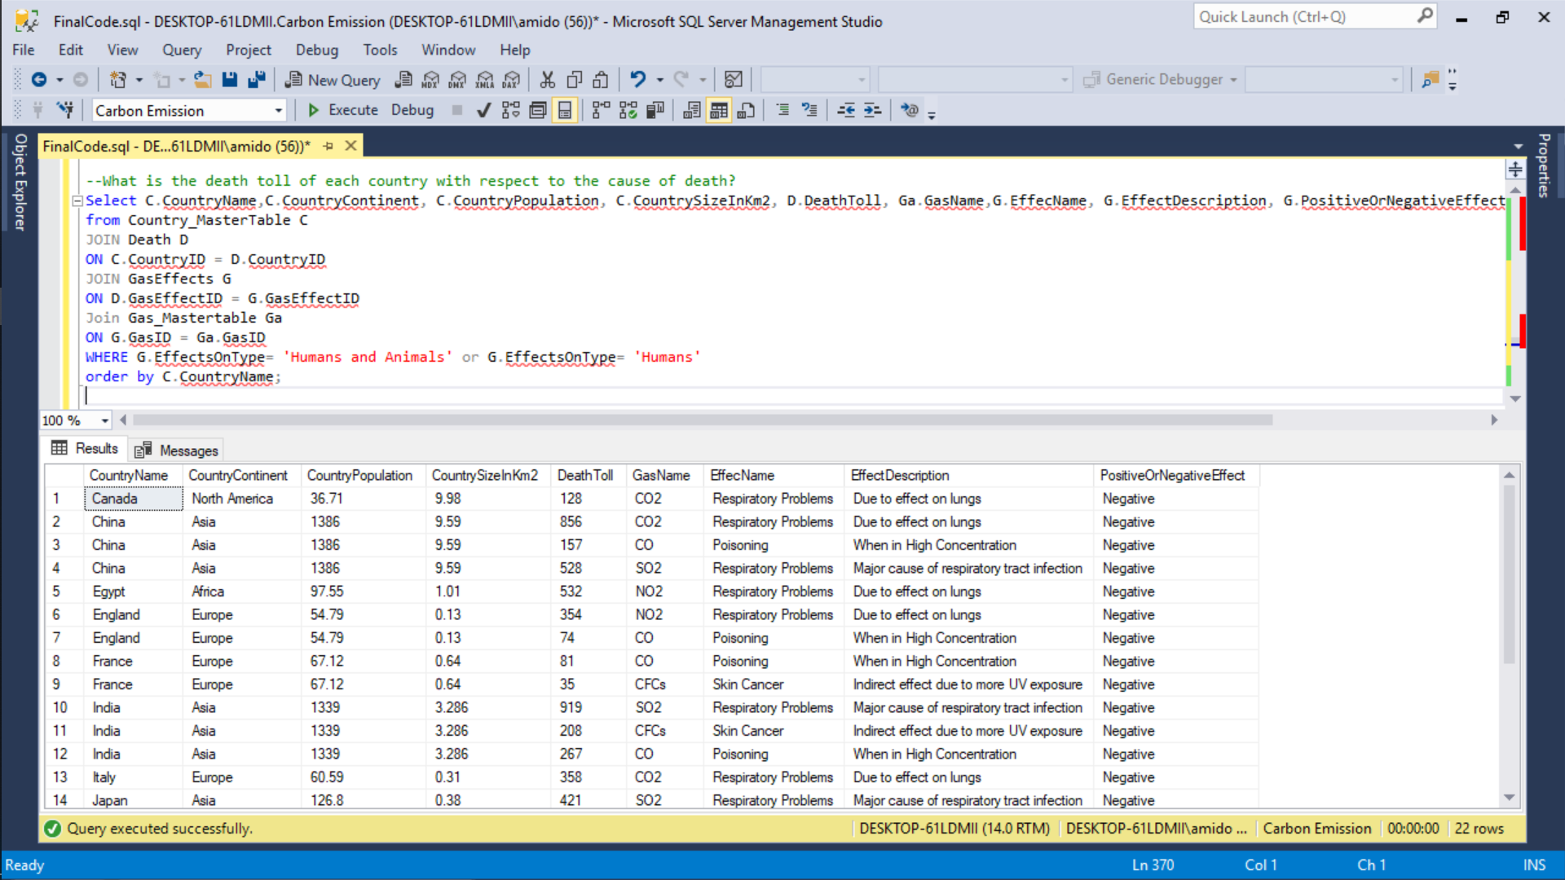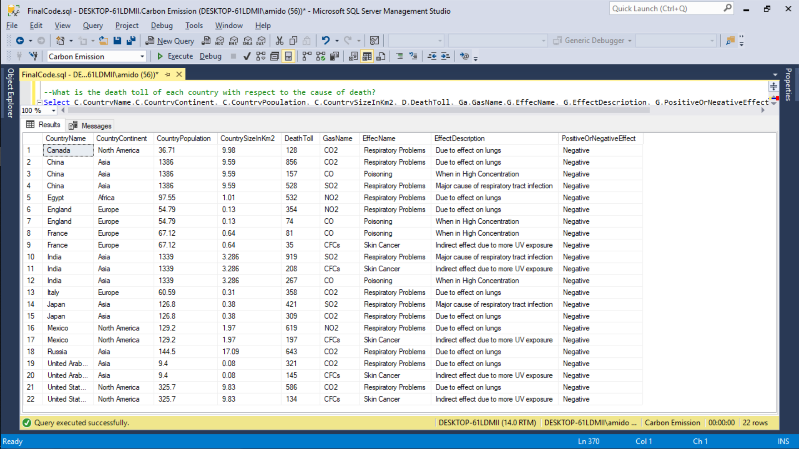

1. What is the carbon monoxide and carbon dioxide levels of each country?

--What is the carbon monoxide and carbon dioxide levels of each country?

Select C.CountryName, C.CountryContinent,G.GasName, CG.GasPercentage, CG.AirQuality, CG.HazardLevel, G.Usage

from CountryGasEffects CG

Join Country_MasterTable C

ON C.CountryID = CG.CountryID

Join Gas_Mastertable G

ON CG.GasID = G.GasID

Where G.GasName = 'CO' OR G.GasName = 'CO2'

Order By C.CountryName;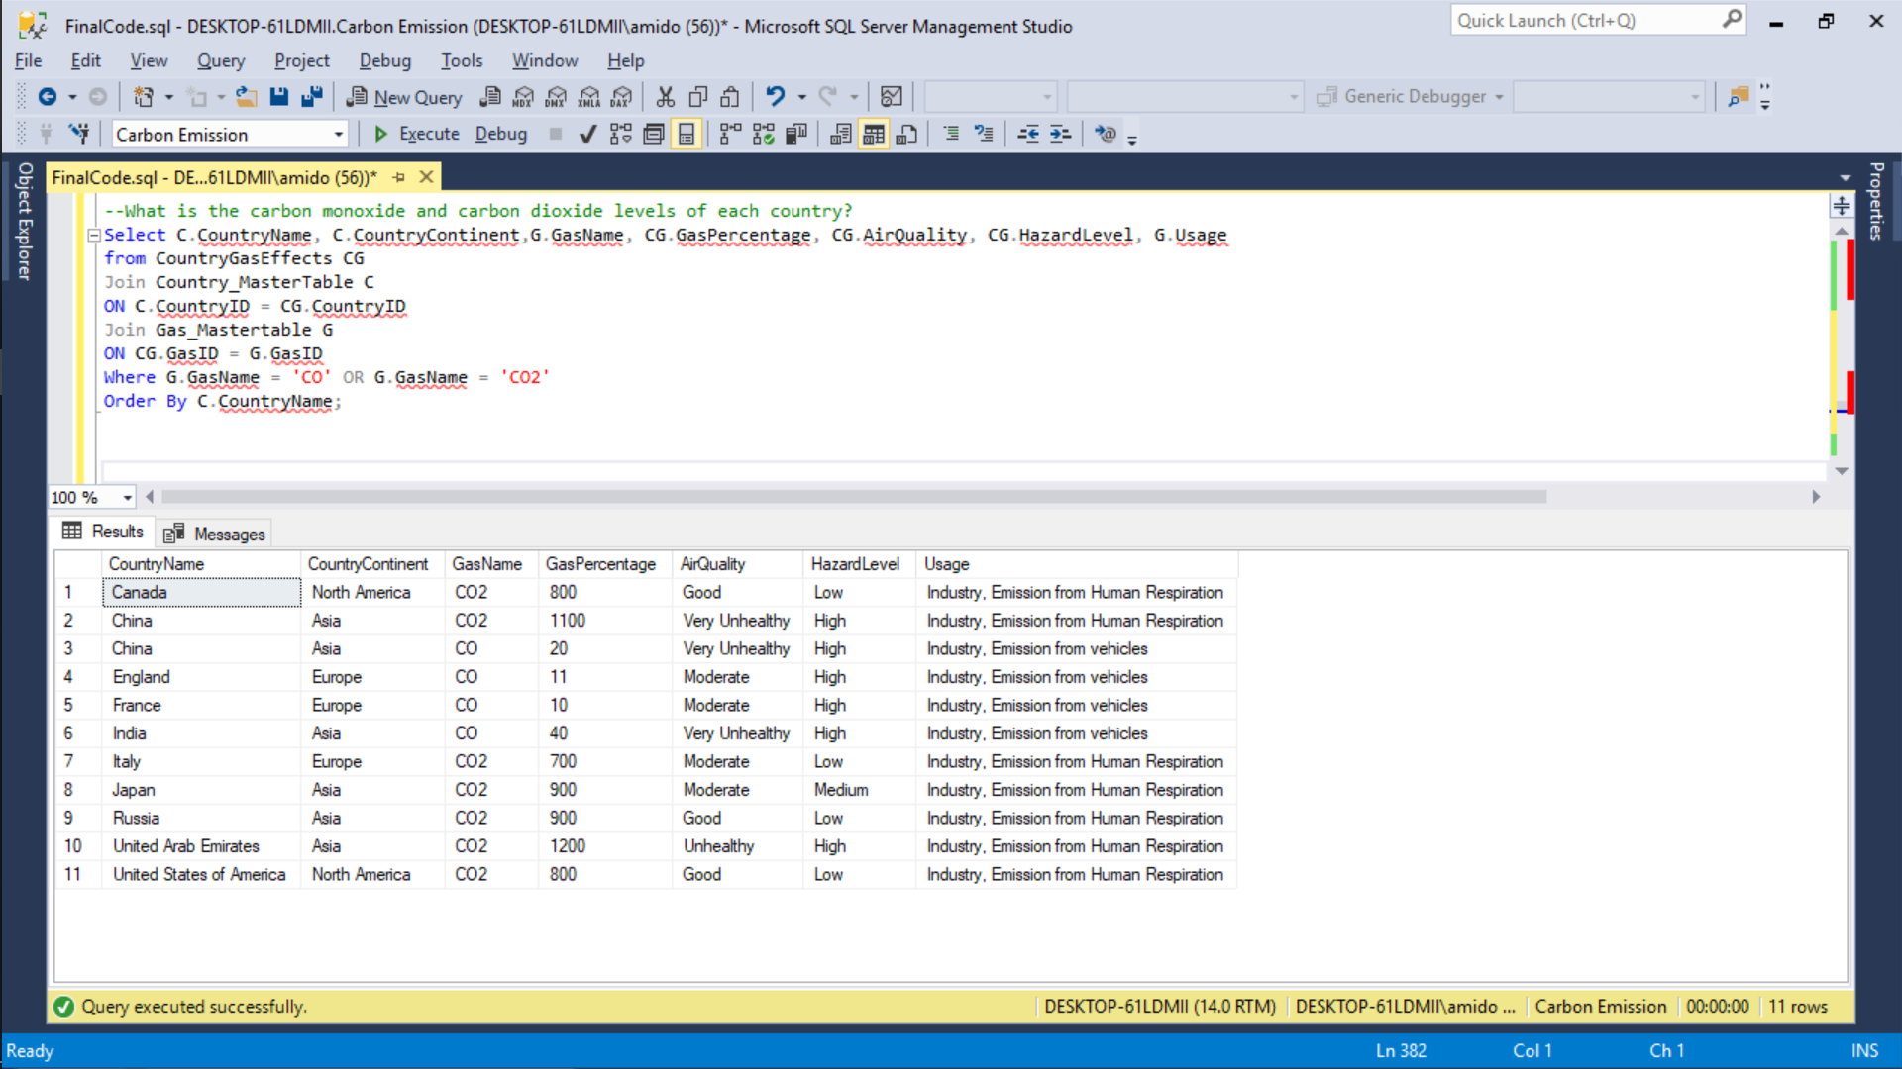

1. Top country for CO and CO2 gas

--Top country for CO and CO2 gas

Select top 3 C.*, G.GasName, CG.GasPercentage

from Country_MasterTable C

Join CountryGasEffects CG

ON C.CountryID = CG.CountryID

JOIN Gas_Mastertable G

ON G.GasID = CG.GasID

Where G.GasName = 'CO'

Order by CG.GasPercentage;

Select top 3 C.*, G.GasName, CG.GasPercentage

from Country_MasterTable C

Join CountryGasEffects CG

ON C.CountryID = CG.CountryID

JOIN Gas_Mastertable G

ON G.GasID = CG.GasID

Where G.GasName = 'CO2'

Order by CG.GasPercentage; 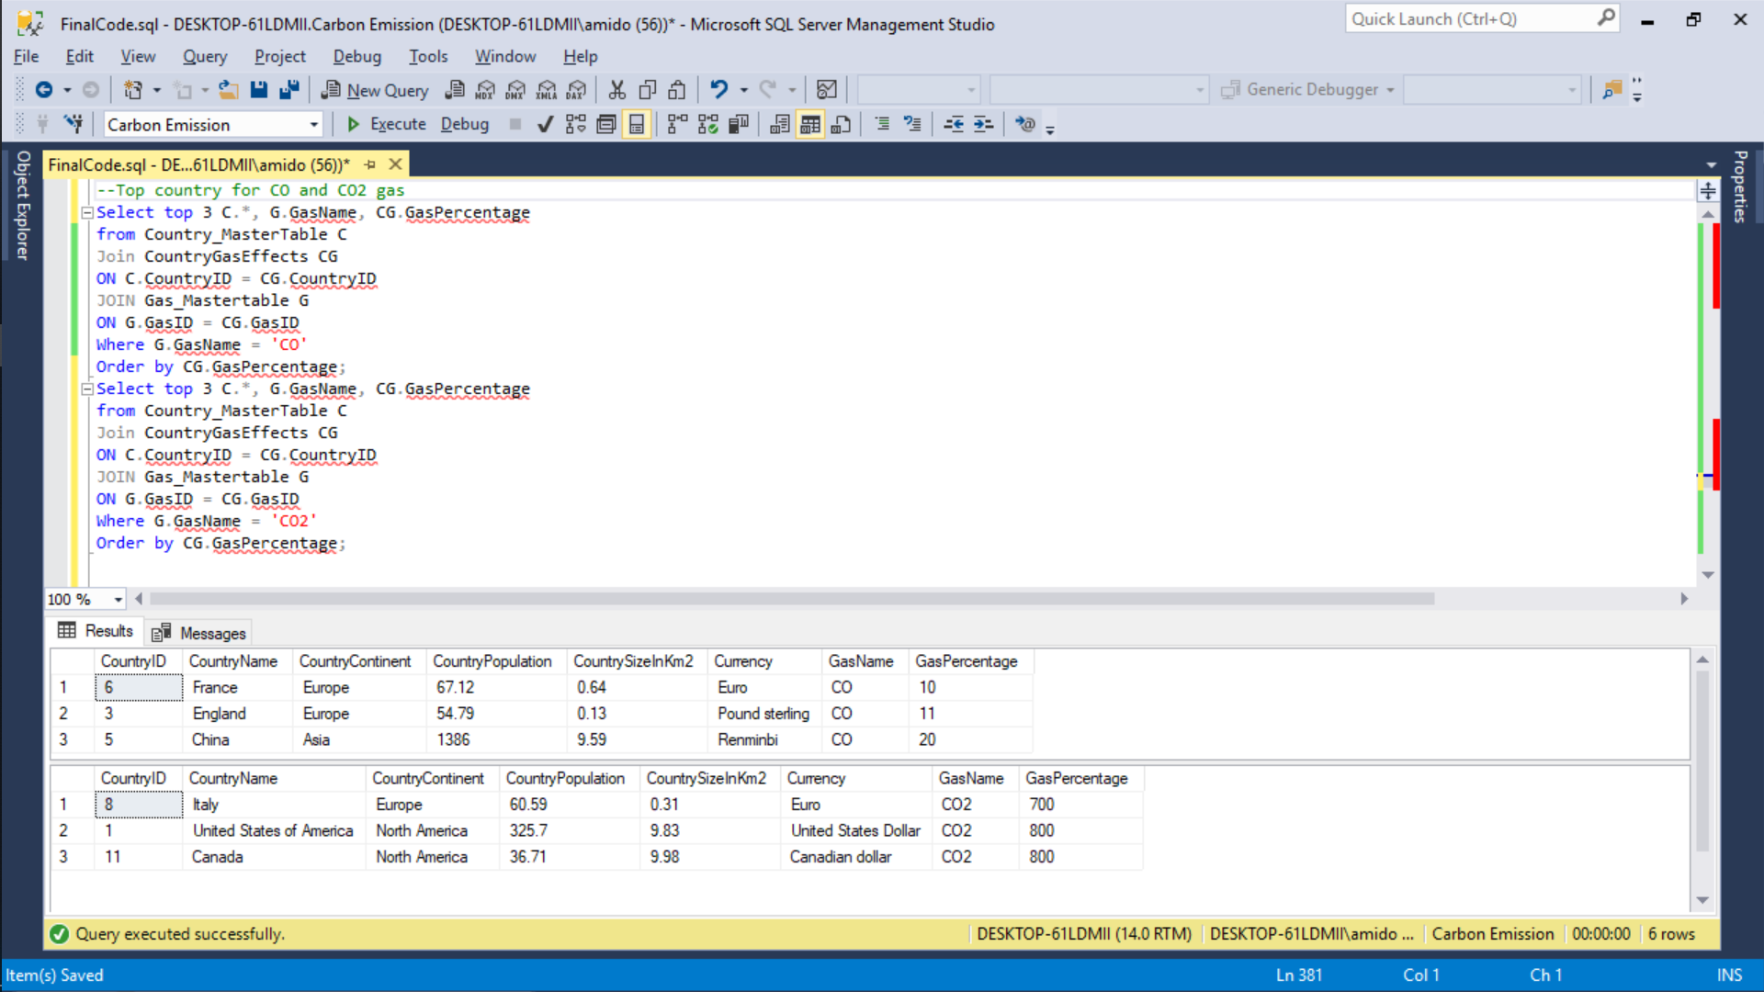

1. **Forms and Reports**

Getting all the data for a particular Gas, say CO2, to find the Countries being affected by it, their death toll, and its effects on environment, humans and animals.

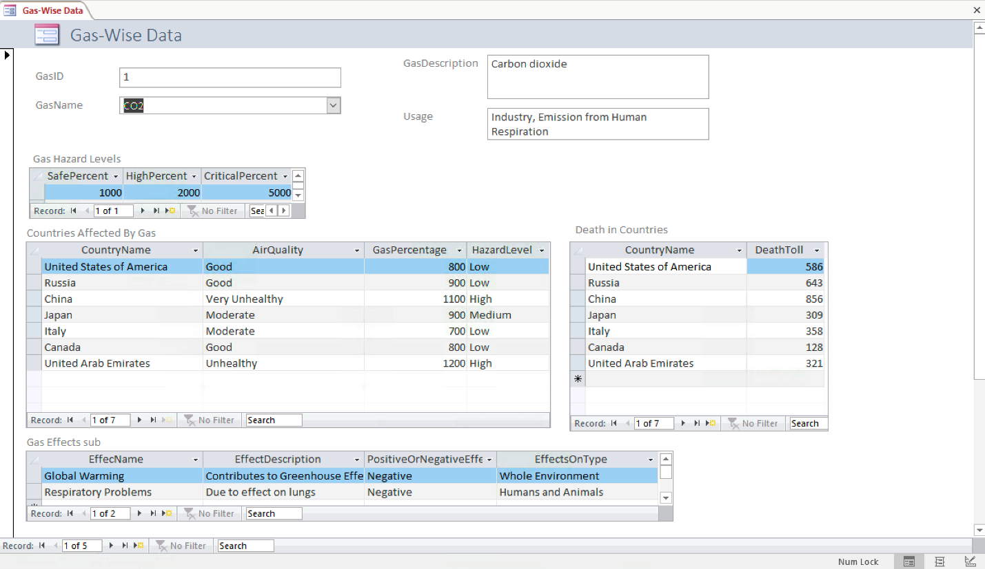

Getting data (including historic data) of a particular country say India, to find its country details, it’s gas levels, death tolls, Environmental effects, and the solutions implemented by the country.

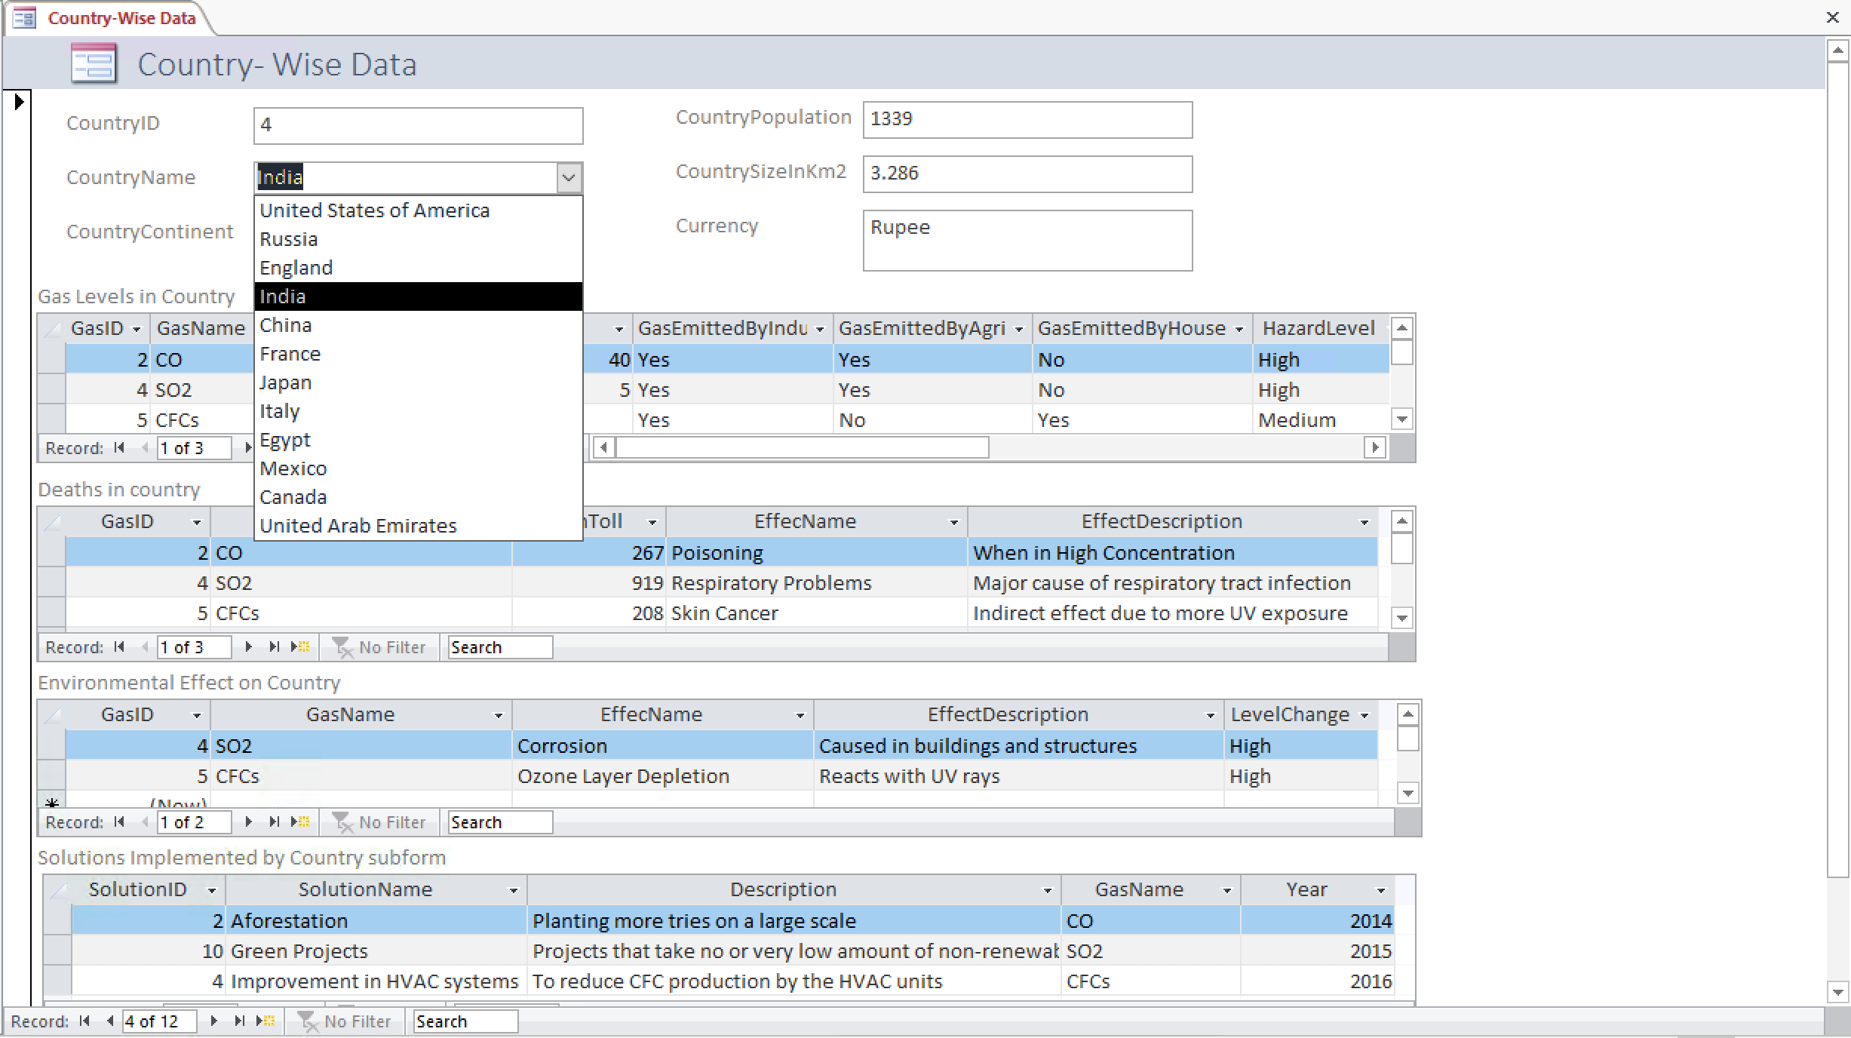

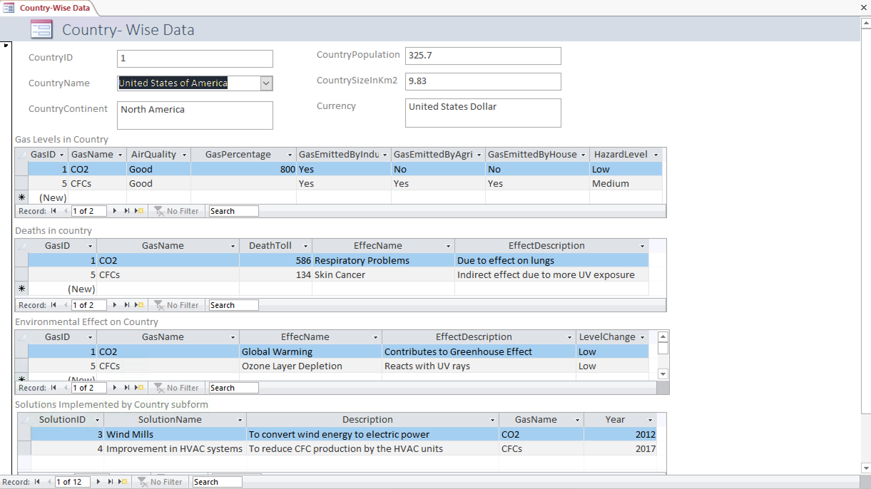

Death Toll Report By country that shows how many deaths took place in a country, responsible gas and the effects caused.

